WORLD SPACE WEEK 2023
(NAMIBIA)
NATIONAL REPORT

1. General Information
National Coordinator:
Full Name: Benyamen Nathanael
Contact Information (bnathanael@ncrst.na, +264813190325):

2. World Space Week 2023 Namibia Overview
Total Number of Events Conducted: 5
Nature of Events
- Presentations
- Exhibitions
- Excursions
- Planetarium shows
- Space talks and career guide
- Telescopes view
Summary of Events:
The celebration began with a high level meeting with senior officials from public and private institutions, academia, and individuals. The meeting featured presentations, exhibitions, and learners guide to careers in space sciences by lecturers from the local universities. This meeting took place on 4 October at Mercure Hotel, Windhoek. Other events were also conducted on the fourth and fifth October in Windhoek. These include the mobile planetarium shows on 4 – 5 October 2023, dedicated to learners so they get inspired to study courses related to astronomy and space science in general.

On Wednesday evening (4 October), the Namibia Scientific Society arranged for space talks and telescopes for people, mostly learners, to see the planet Saturn and its rings and moons with their own eyes. Finally, on Friday 6 October, NCRST arranged an excursion to the High Energy Stereoscopic System (H.E.S.S.), the largest telescopes, the largest telescopes in the gamma-ray astronomy worldwide. These telescopes are located about 100km South of Windhoek, Namibia.

3. Highlighted Events and Stories
1.
Event Details
Event Name: National Workshop for the celebration of the World Space Week Namibia
The event was organized by the National Commission on Research, Science and Technology and the Ministry of Higher Education, Technology and Innovation. It has attracted presentations on Namibia Space Science and Technology Policy, Satellite systems and solutions, National Ozone Unit of Namibia's efforts to protect and save the Ozone Layer from depletion; and applications for satellite technology and earth observation in wetland monitoring.
The afternoon was dedicated to lectures – learners interactions. Lecturers from the Namibia University of Science and Technology (NUST) and the University of Namibia (UNAM) presented opportunities in space science, within the fields of astronomy, astrophysics, earth observation, reengineering and data analytics.

Location: Windhoek
Date and Time: 4 October 2023, 08h00 – 16h30
Nature of Event: Workshop
Number of Participants (if available): 110
Breakdown by Age Group (if available): ~80 below 20 (learners) and ~ 30 adults
Breakdown by Gender (if available): Not available
Notable Stories:
Namibia has launched its first policy on space science and technology in 2021. Participants were urged to scale up the activities to contribute to the implementation of this policy. The event has also graced with several exhibitions, including some from South Africa.
Links to Event Coverage:
https://www.facebook.com/search/top/?q=ncrst%20space%20week
https://www.namscience.com/article/world-space-week

Photos:

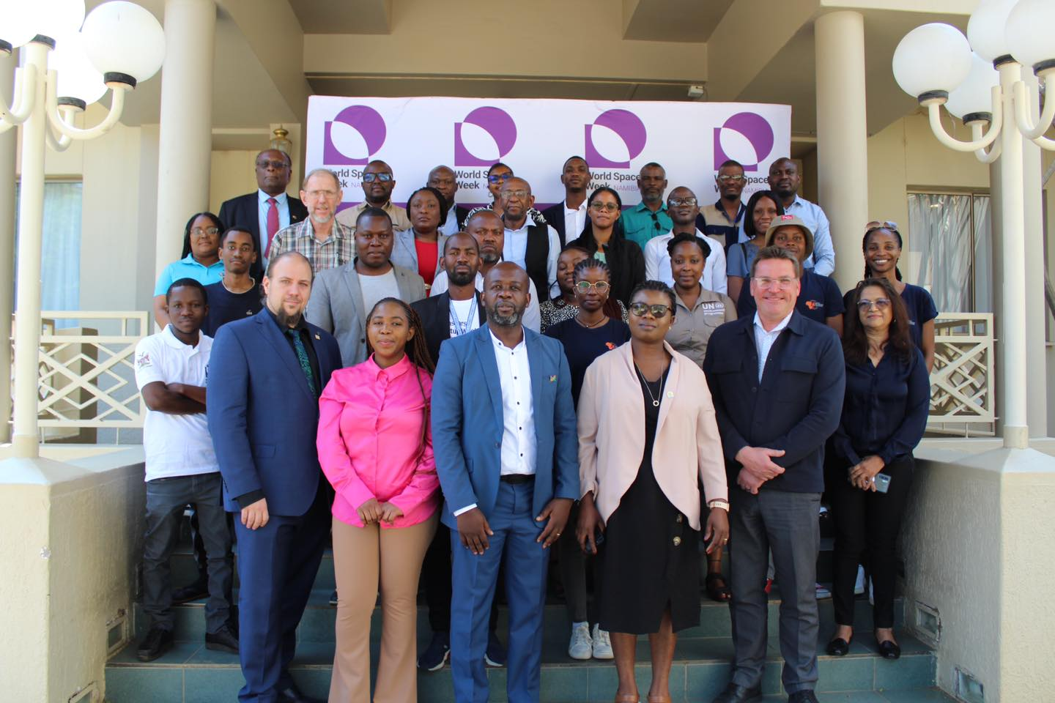

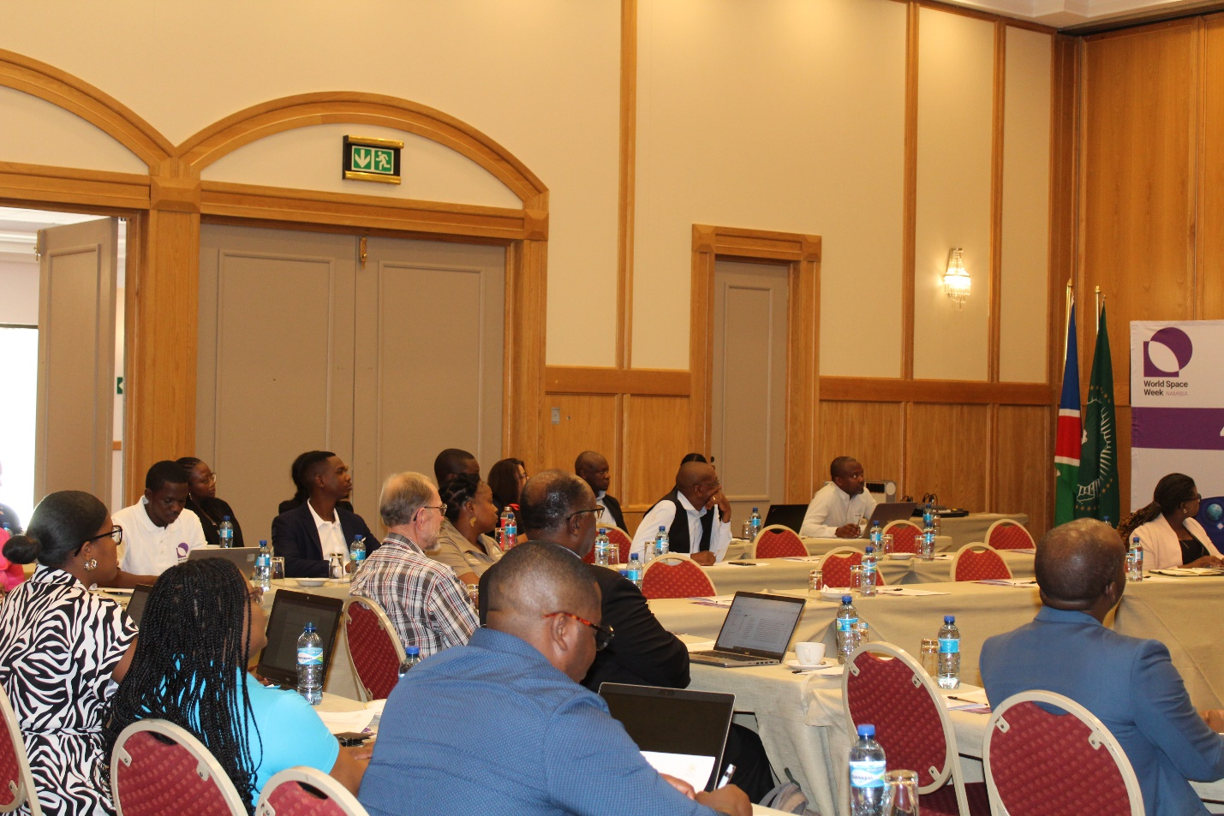
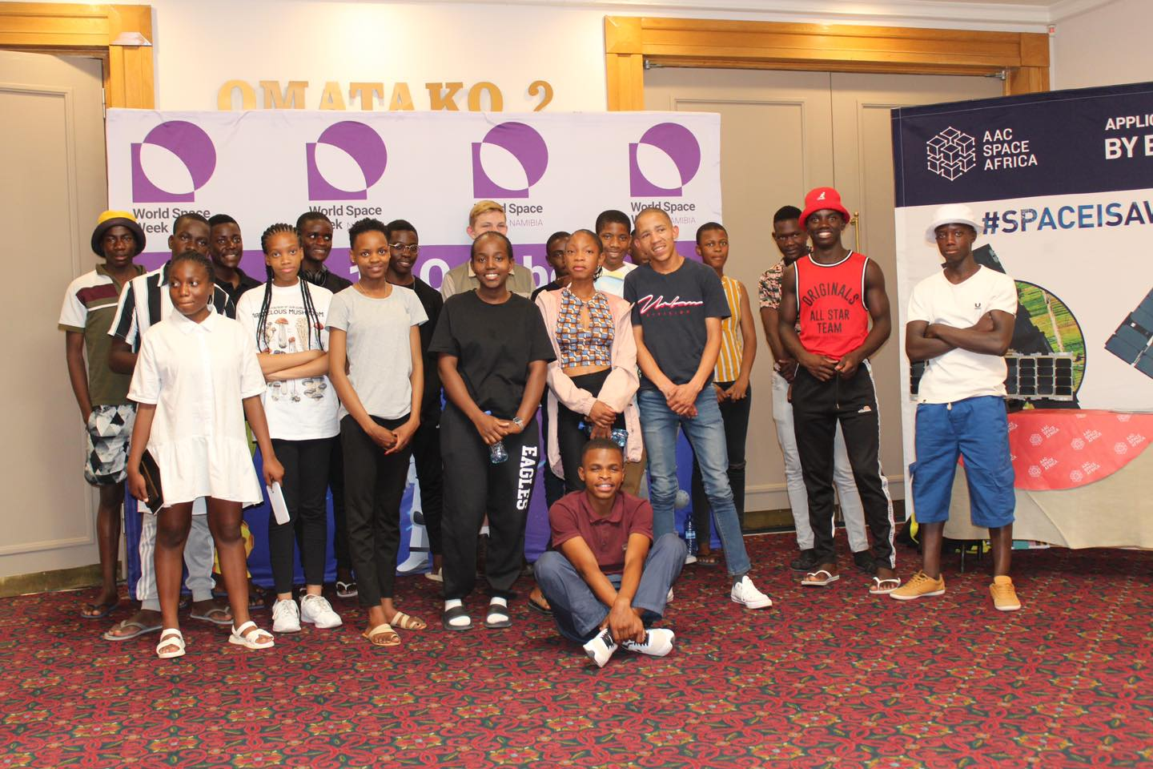

2. Planetarium shows
The NCRST have coordinated with the University of Namibia and the Africa Milimetre Telescope Project to have the mobile planetarium available to learners (and the general public) during the World Space Week. The overall aim is to inspire learners and to have the general public appreciate space science by having a closer picture of the space environment.
Date and Time: 4 and 5 October 2023, 09h00 – 16h00
Nature of Event: Show / exhibition
Number of Participants (if available): >100
Breakdown by Age Group (if available): ~80 below 20 (learners) and ~ 20 adults
Breakdown by Gender (if available): Not available

Links to Event Coverage:
The same event was posted with the main workshop on NCRST Facebook page: https://www.facebook.com/search/top/?q=ncrst%20space%20week

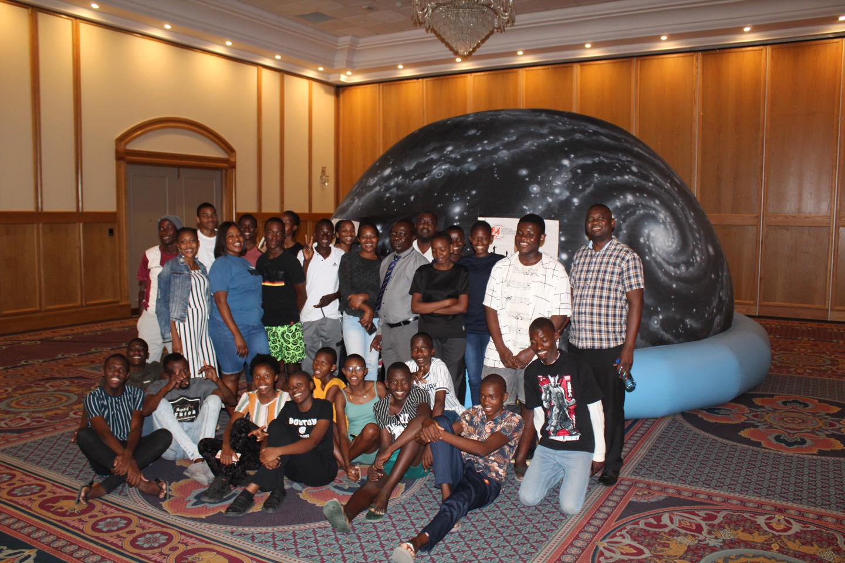
Photos:

3. Excursion to the High Energy Stereoscopic System (H.E.S.S.) site
During the World Space Week, NCRST organized an excursion to the High Energy Stereoscopic System (H.E.S.S.), a site where the H.E.S.S. experiment takes place. The site has five telescopes that are used by the H.E.S.S. Collaboration, a group consisting of about 20 institutions worldwide studying the high energy—or Gamma Ray Astronomy. The purpose of the visit is to promote awareness for space science and technology by showing some key infrastructures in Namibia.

Location: Farm Goellschau, about 100 km south-west of Windhoek (23°16′17″S 16°30′00″E)
Date and Time: 6 October 2023, 09h00 – 14h00
Nature of Event: Excursion
Number of Participants (if available): 35
Breakdown by Age Group (if available): Not available
Breakdown by Gender (if available): Not available
Notable Stories:
Participants were very excited to the telescopes. The telescopes were operated briefly to show how the data is being collected. Interest was especially expressed to improve and showcase such topics in the education curriculum.
An emerging issue of light pollution was identified as one that may affect astronomy activities in Namibia. Therefore, it was highlighted that as Namibia aspires to industrialize, here is a need to regulate the light so that it does not shine into the sky but rather downward where it is needed the most.
Links to Event Coverage:
https://www.facebook.com/ncrst.na?__cft__[0]=AZUzIOleT-Dg08aRdDDkh-y2PbcWeh6-oaQwFKc5KwbMympkjx-AotvGv8ZXJhqEFSlOpQ-8kV68RTrKZeSiTm5eAj0Q220-X_M1HtvKhPHZuJjcFjALf92GQ9uou8b7-3ZQb3IJIeeqbdOgj6kx0vAGSJ65IFNvnfYz1akTt3f0zE897FACua6s7DjyPanrqTs&__tn__=-UC%2CP-R

Photo(s):

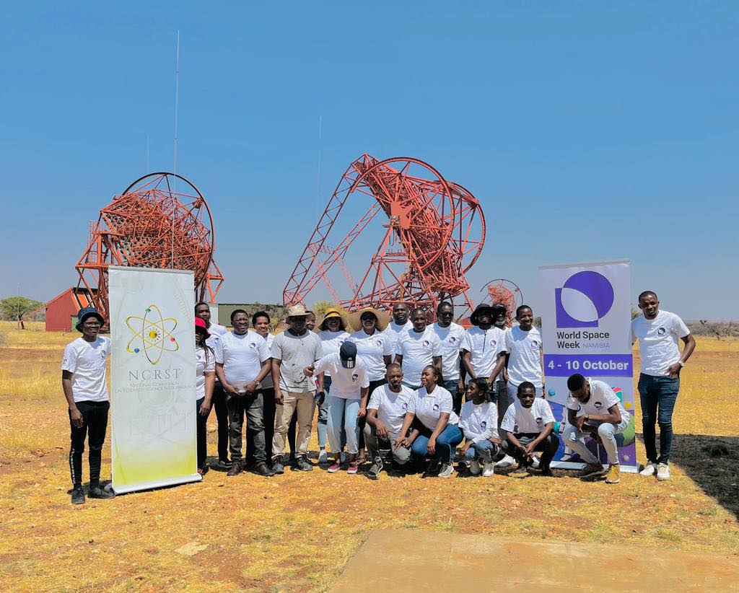
4. Space talks and telescopes view
In the evening (4 October 2023), the Namibia Scientific Society organized space talks to present astronomical activities happening in Namibia and why

Namibia is one of the best sites for astronomy in the world. Later in the evening, guests were able to use telescopes to view Saturn and its rings and moons with their own eyes.

Date and Time: 4 October 2023, 19h00 – 22h00
Nature of Event: Talks / exhibition
Number of Participants (if available): ~150
Breakdown by Age Group (if available): ~120 below 20 (learners) and ~ 30 adults
Breakdown by Gender (if available): Not available

Notable Stories:
Guests, especially young ones were fascinated and had their questions answered by astronomers.
Links to Event Coverage:
https://www.namscience.com/article/world-space-week

Photos:
Photos for this event are available on Namibia Scientific Society Website: https://www.namscience.com/article/world-space-week

4. Media and Social Media Engagement (if available)
Social Media Impressions
A call for participation and exhibition at the World Space Week was advertised in the local papers and social media. The sample of the call is presented below, and the link beneath it.
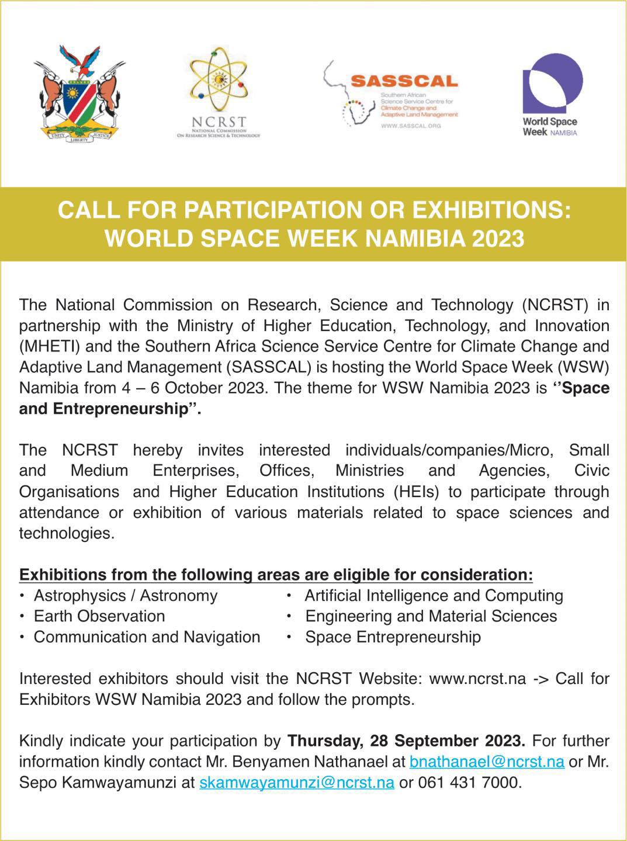

Link: https://www.facebook.com/ncrst.na?__cft__[0]=AZWquR_0rdSbn-Ev5R9zoRHv-VMTo6xw5dVk1p4FfiKLMkfVog9dYxyCbtrPaFEVb2DTeAK-VpYd8UIBe-vz5icMCU8tSA9thAHeZwDf1QWl2XDzNANi3LqEXZ_pJthMk2S7Vmo8X0H_oCfdCPcaS7CeYe0QZqLnFGLfmvTXdLf6AyOXPRF833znduav1t3Qqq4&__tn__=-UC%2CP-R

Media / News Coverage:
You may list as many as possible / available.
Reach (Local, National):
https://www.sciencetechniz.com/2023/10/namibia-celebrates-world-space-week.html
https://www.facebook.com/search/top/?q=ncrst%20space%20week
https://www.namscience.com/article/world-space-week

5. Additional Efforts (if available)
1. Press Releases:
A press release was issued on 4 October and appeared in a local newspaper. The sample of the press release is presented below.

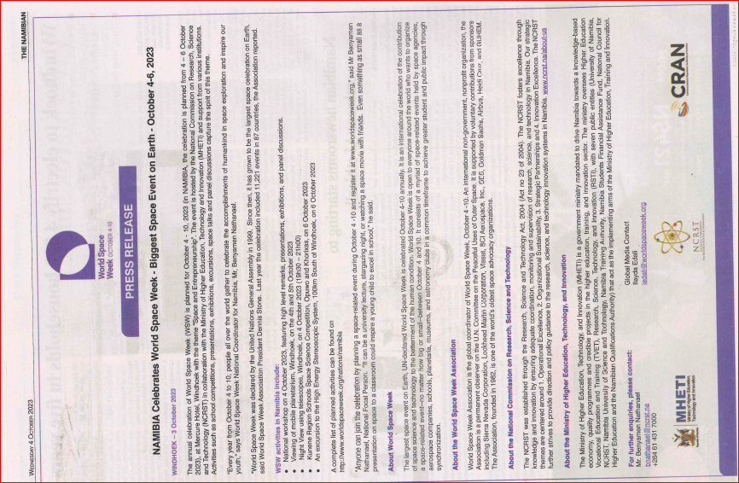

2. Additional Information:
1. The fifth event that was planned to take place in the region could not materialize at the last minute. However, a lot of planning and contacts was made which serves as a ground for a successful space competitions in schools from next year.
2. Although Namibia has had a few space week celebrations in the past, this is the first time it is happening at this scale and magnitude. Therefore, a committee will be established consisting of various stakeholders that will spearhead the celebration of the Space Week from 2023.

