Please feel free to use the World Space Week logo of your country on the Header.
Please feel free to customize this page with different designs, additional logos and images.

WORLD SPACE WEEK 2023
Saudi Arabia
NATIONAL REPORT

1. General Information
National Coordinator:
Full Name: Mohamed Saeed Barzig
Contact Information (Email, Phone): alailmi2008@gmail.com

2. World Space Week 2023 (Your Country) Overview
Total Number of Events Conducted: 7220
Nature of Events
(e.g., competitions, ceremonies, school events, online activities, webinars, etc.)
Summary of Events:
Brief overview of the events and their impact:
The ministry wrote a circular and distributed it to all education administrations in all regions of the kingdom. a coordinator has been selected in every education administration. This coordinator made a circular for all the schools and scientific centers in relation to every education administration in relation with the ministry of education according to a frame that had been sent to him. then every coordinator has been followed up via whatsapp and zoom.
The students started executing many activities via competitions, ceremonies, school events, online activities, webinars and exhibitions.

3. Highlighted Events and Stories
1. Space and Entrepreneurship
Event Details
Event Name: Space and Entrepreneurship
Description: - Through the school radio station for a full week from Sunday, October 8, at seven in the morning until Thursday, October 10, we introduced the world of space to the attendees. 2- Holding competitions on space, entrepreneurship, and coloring, and handing out prizes to the winners. 3- Students’ participation with drawings and pictures through the art gallery held at the school.
Location: Arar
Date and Time: 8th October 2023 to 12th October 2023
Nature of Event (e.g., competition, ceremony, school event, online activity, webinar, etc.): school event
Number of Participants (if available):
Breakdown by Age Group (if available): Primary school
Breakdown by Gender (if available): female
Notable Stories:
Please provide any impressive or impactful stories from the event to be considered for a feature in the annual report.
Links to Event Coverage:
(e.g., LinkedIn, Facebook, Twitter posts/pages, news articles, Youtube videos)
1. Enables students to learn about the world of space
2. Drawing beautiful paintings about the world of space
3.Coloring competition
4. A competition about the world of space 5-Delivering prizes to the winners
Photos:
Please include images at the end of each event listed as Highlights and Stories, if available, with the World Space Week logo depicted within them.

(Repeat the above for each highlighted event)
2.
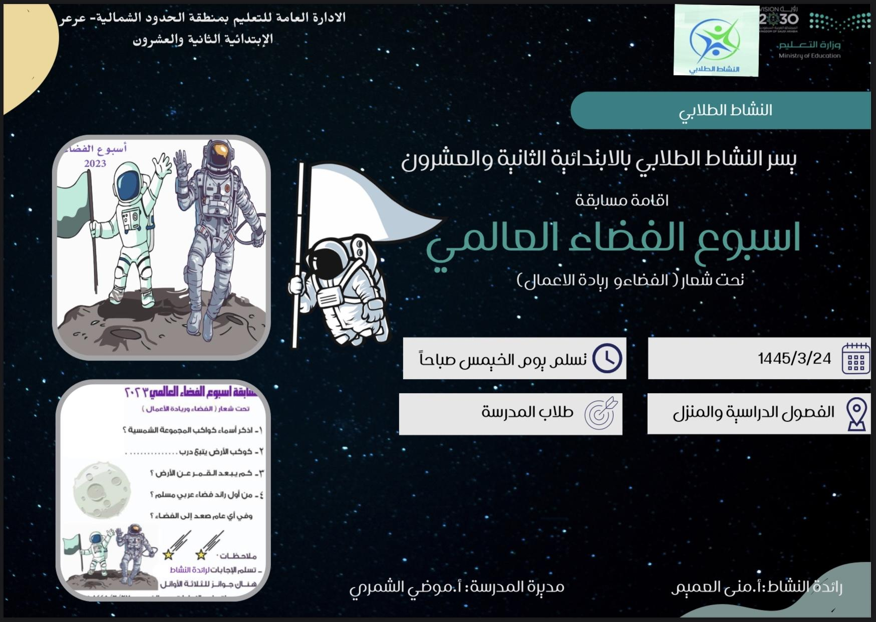

3.
4.
5.

4. Media and Social Media Engagement (if available)
Social Media Impressions
Please provide a platform-wise breakdown:
Twitter
Media / News Coverage:
You may list as many as possible / available.
Reach (Local, National):

5. Additional Efforts (if available)
1. Press Releases:
Details of press releases or other promotional efforts undertaken by the NC.
some activities have been released in national newspapers, channels.
Some schools received Ikhbaria channel, and received foreign astronauts and Saudi astronauts about space entrepreneurships.
2. Additional Information:
Any other relevant information or notable achievements.
memorandum of integrity between the ministry of education and the Saudi space agency. Many programs (ex. space generation, minor gravity experiments which have been executed in Saudi schools in accordance with experiments from Saudi astronauts in the international station.

