WORLD SPACE WEEK 2023
PORTUGAL
NATIONAL REPORT

1. General Information
National Coordinator:
Full Name: Cláudio Filipe Vieira Gomes
Contact Information (Email, Phone): claudiogomesspace@gmail.com

2. World Space Week 2023 Portugal Overview
Total Number of Events Conducted: 12
Nature of Events
This year, we had 1 ceremony, 2 public exhibitions, 6 school events, 1 night sky observation, 2 planetarium sessions.
Summary of Events:
The kick-off ceremony of the World Space Week in Portugal had two talks for the general audience and schools (4 schools engaged) in about 120 people, and took place in the Azores. One public and interactive exhibition concerning the Universe, Physics and Astronomy was held in one shopping centre in the Azores for the general public. Another public exhibition was about astrophotography of a Portuguese photographer in Góis. There were school events promoted in the Azores (Terceira and São Miguel islands), in Gouveia, in Moimenta da Beira, in Paredes, and in Madeira island. One night sky observation was held at the Astronomical Observatory in the Azores. One planetarium session was held in Espinho and another in the Azores.

3. Highlighted Events and Stories
1.
Event Details
Event Name: Espaço, empreendedorismo e observação da Terra (Space, Entrepreneurship and Earth Observation)
Description: National kick-off ceremony of the World Space Week with two talks: one by the National Coordinator and Researcher Cláudio Gomes, and the other by the Earth Observation expert Mariana Ávila.
Location: Auditorium of the Ponta Delgada Public Library
Date and Time: October 4th, at 10:00 am
Nature of Event: Ceremony
Number of Participants (if available): 120
Breakdown by Age Group (if available): 14-18: about 110; others: 10
Breakdown by Gender (if available):
Notable Stories:

Links to Event Coverage:
https://spaceazores.pt/en/world-space-week-2023/
https://portal.azores.gov.pt/web/comunicacao/news-detail?id=12283929
https://portal.azores.gov.pt/web/comunicacao/news-detail?id=12353295
https://www.rtp.pt/play/p1249/e719432/jornal-das-13-00
https://correiodosacores.pt/NewsDetail/ArtMID/383/ArticleID/47866/Lan231ada-ontem-a-Semana-Mundial-do-Espa231o-2023-em-Ponta-Delgada

Photos: (credits to https://portal.azores.gov.pt/web/comunicacao/news-detail?id=12353295)

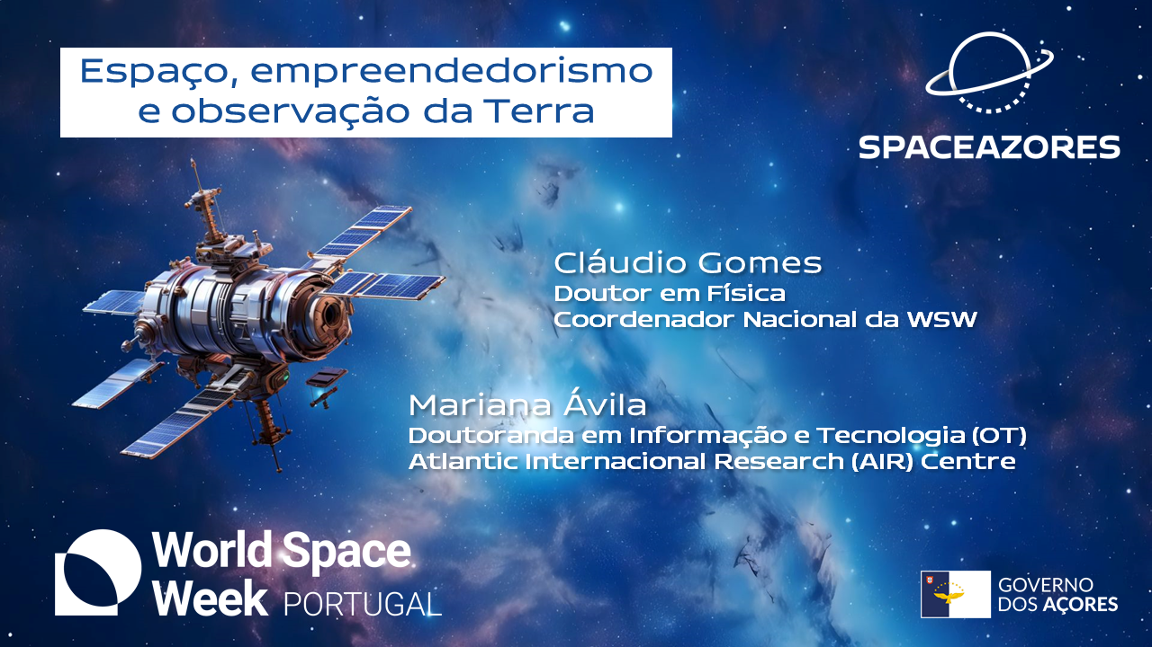
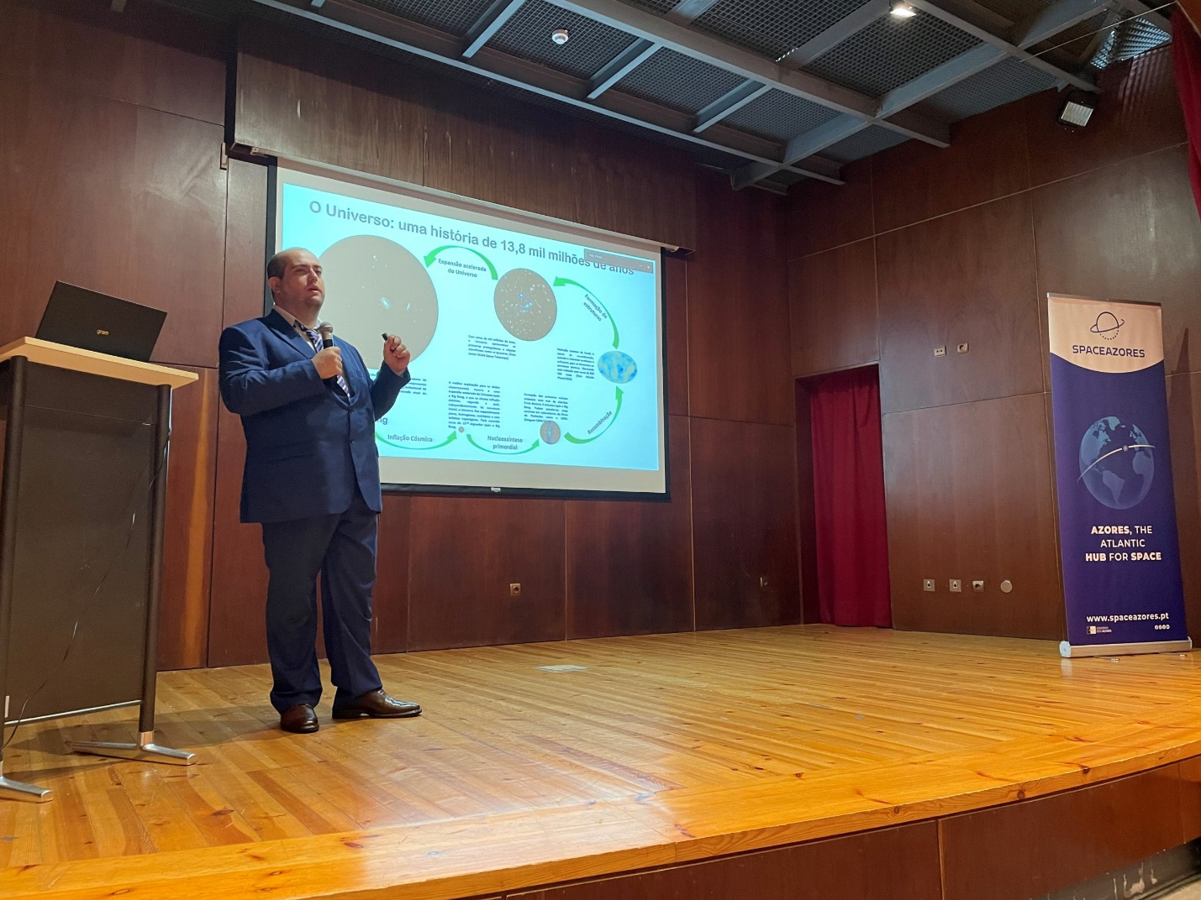
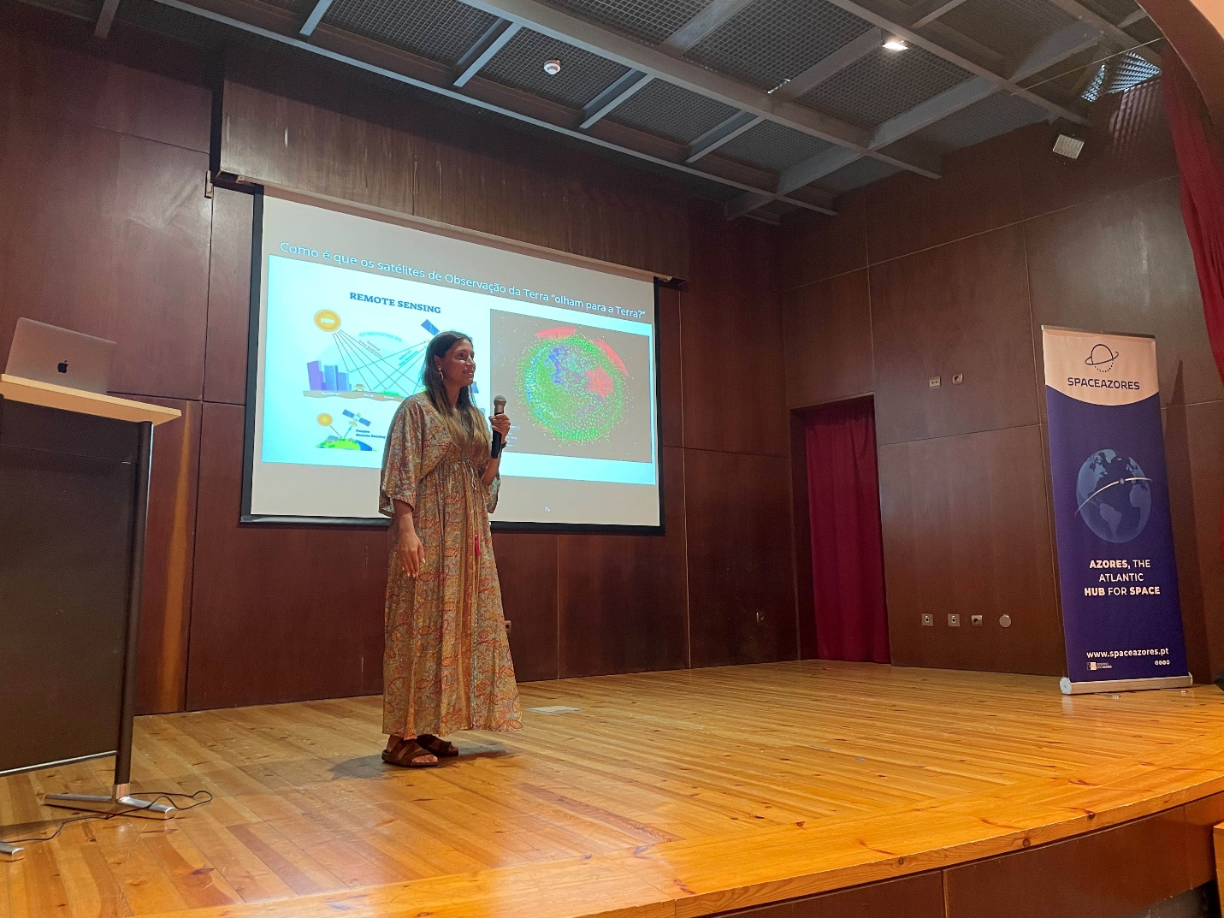
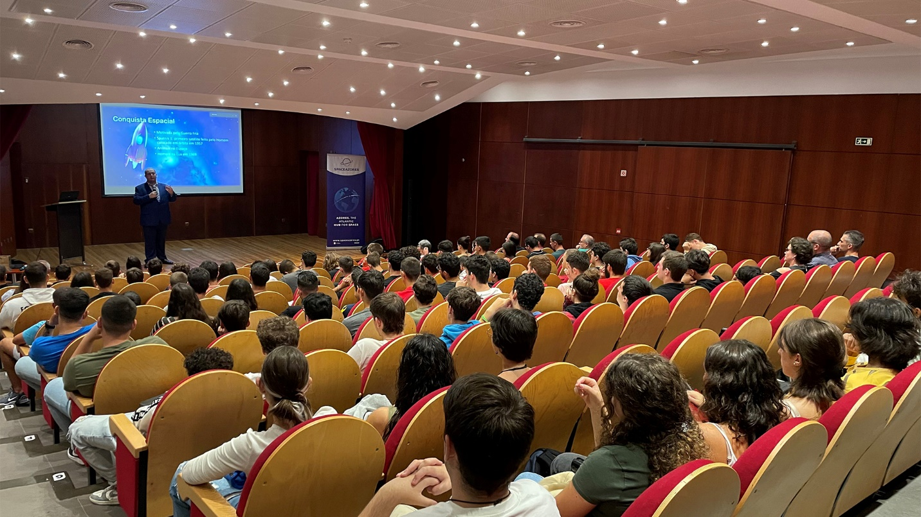

2.
Event Details
Event Name: O Universo vem aos Açores
Description: Public and interactive exhibition at the Shopping Centre Parque Atlântico.
Location: Shopping Centre Parque Atlântico
Date and Time: October 5th, 6:00 pm, until October 13th, 10:00 pm
Nature of Event: Exhibition
Number of Participants (if available):
Breakdown by Age Group (if available):
Breakdown by Gender (if available):
Notable Stories:
This exhibition includes a module developed by the students of Mechanical and of Electrotechnics and Computers from the University of the Azores representing the basics of the operation of a radiotelescope.
Links to Event Coverage:
https://correiodosacores.pt/NewsDetail/ArtMID/383/ArticleID/47843/Fotografias-de-astrofot243grafos-dos-A231ores-v227o-estar-patentes-em-exposi231227o-sobre-o-Universo-no-Parque-Atl226ntico
https://noticias.uac.pt/exposicao-o-universo-vem-aos-acores/
https://www.acorianooriental.pt/noticia/exposicao-interativa-convida-a-explorar-o-universo-354403
https://news.cision.com/pt/sonae-sierra/r/exposicao-leva-os-misterios-do-universo-aos-acores,c638321945710000000

Photos: (credits to João Porto)
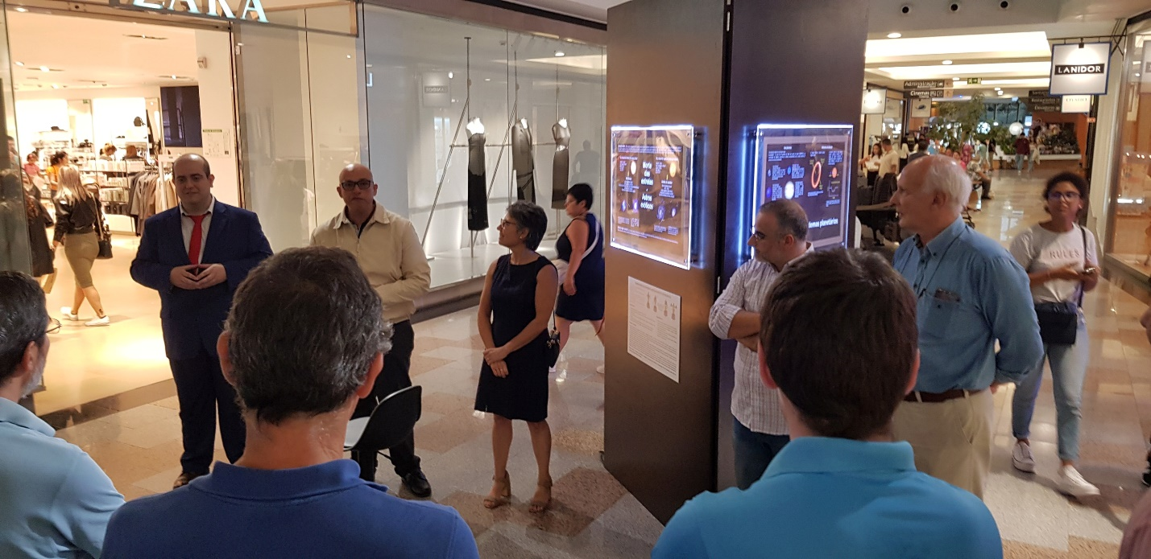
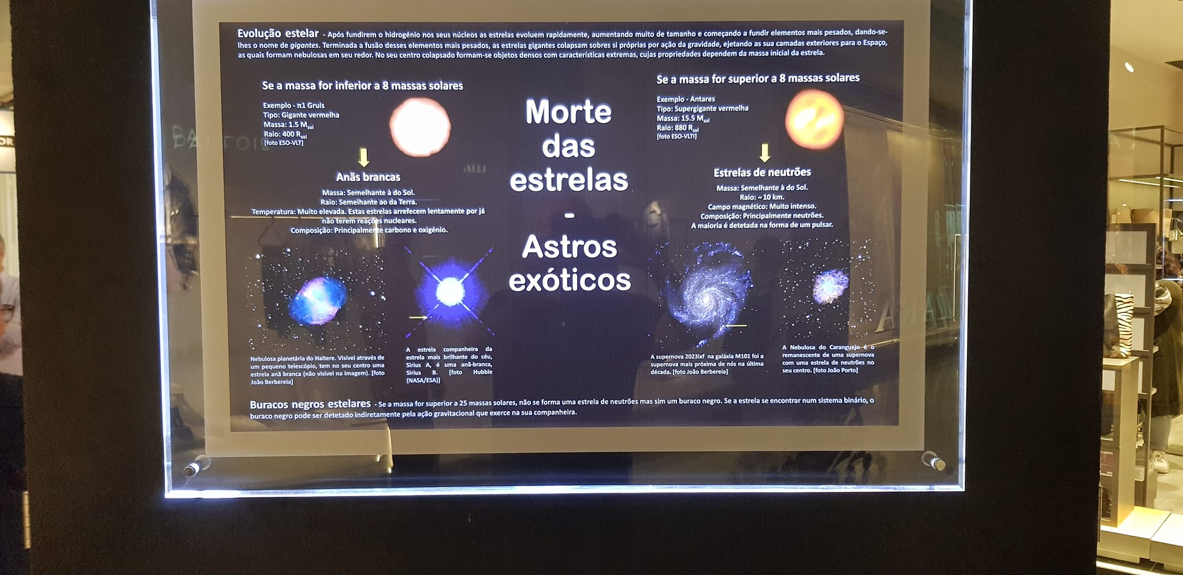

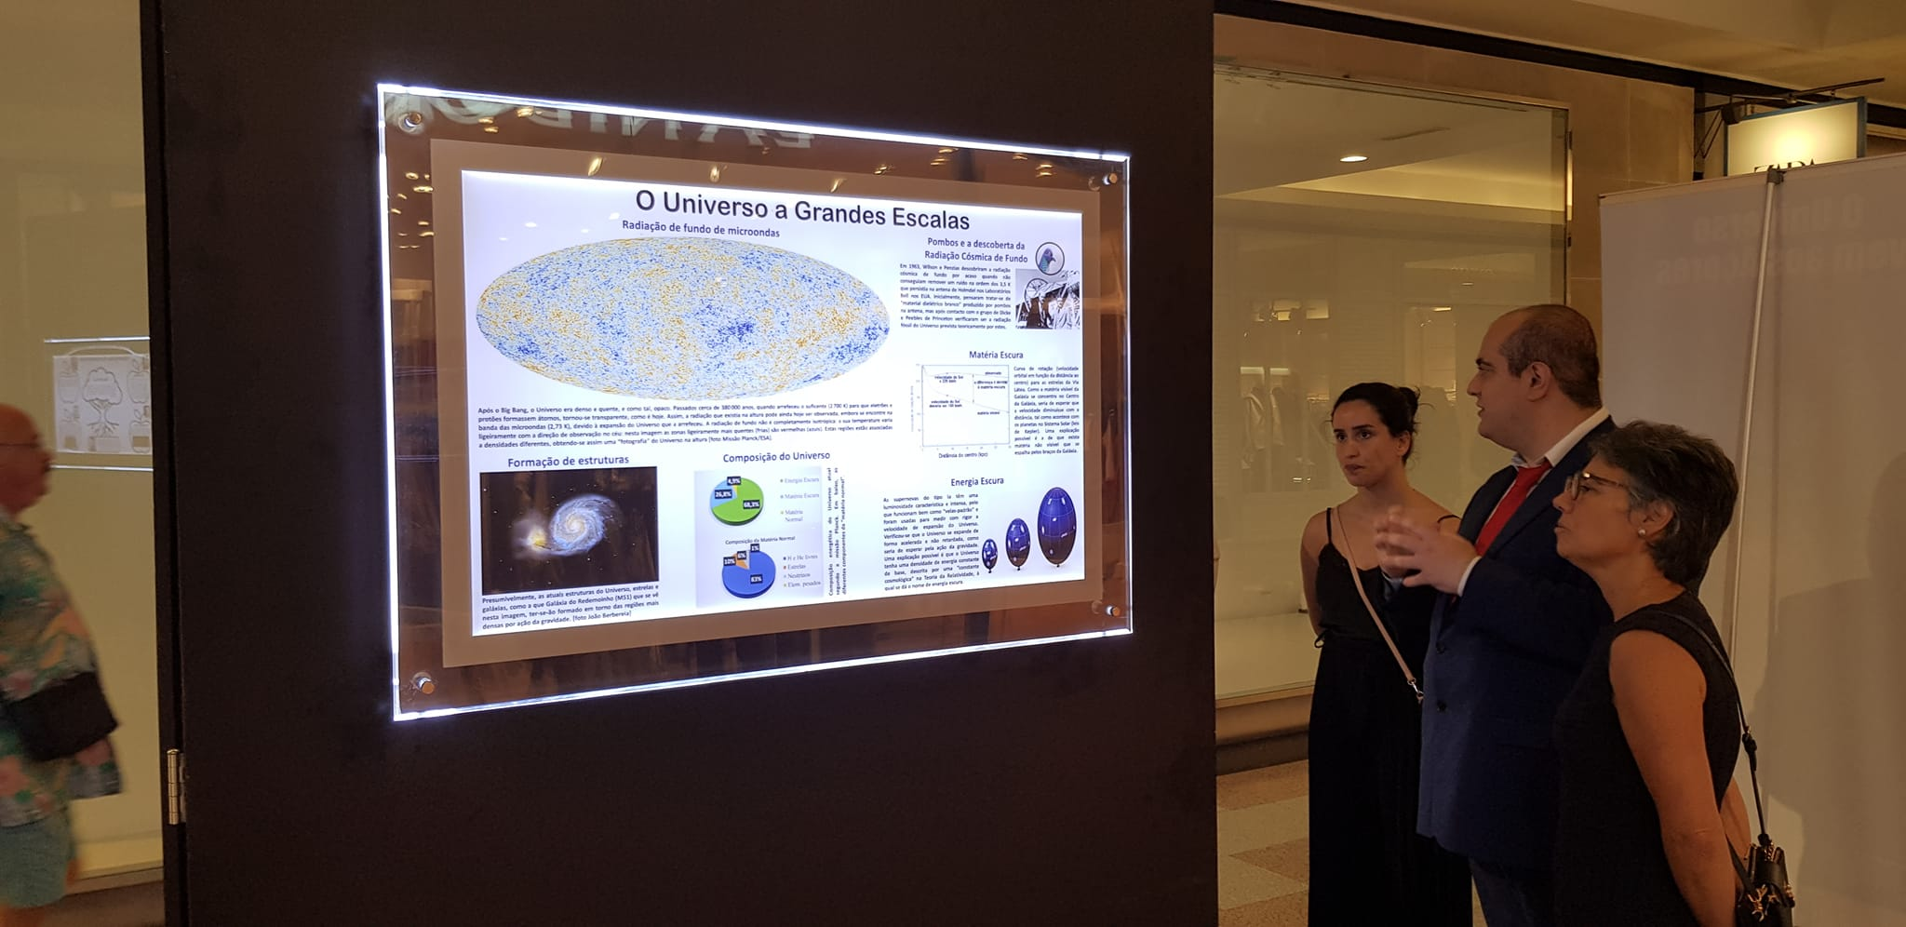

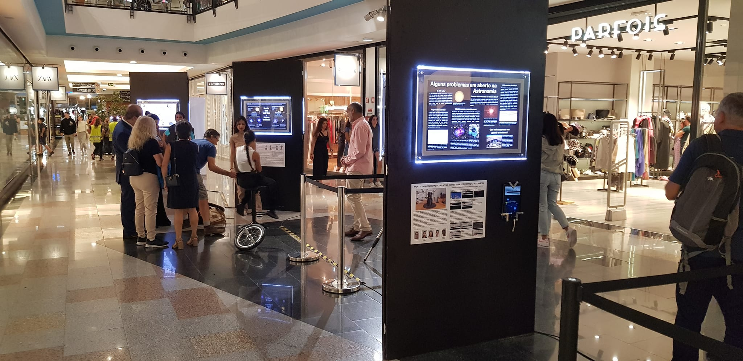

3.
Event Details
Event Name: Exposição Temporária de Astrofotografia, de Bruno Gonçalves
Description: Exhibition on astrophotography
Location: Casa da Cultura de Góis, Góis, Coimbra
Date and Time: October 5th to October 31st
Nature of Event: Exhibition
Number of Participants (if available):
Breakdown by Age Group (if available):
Breakdown by Gender (if available):
Notable Stories:

Links to Event Coverage:
https://www.cm-gois.pt/municipio/comunicacao/noticias/noticia/gois-exposicao-de-astrofotografia-integra-a-semana-mundial-do-espaco

Photos: (credits to https://www.cm-gois.pt/municipio/comunicacao/noticias/noticia/gois-exposicao-de-astrofotografia-integra-a-semana-mundial-do-espaco)
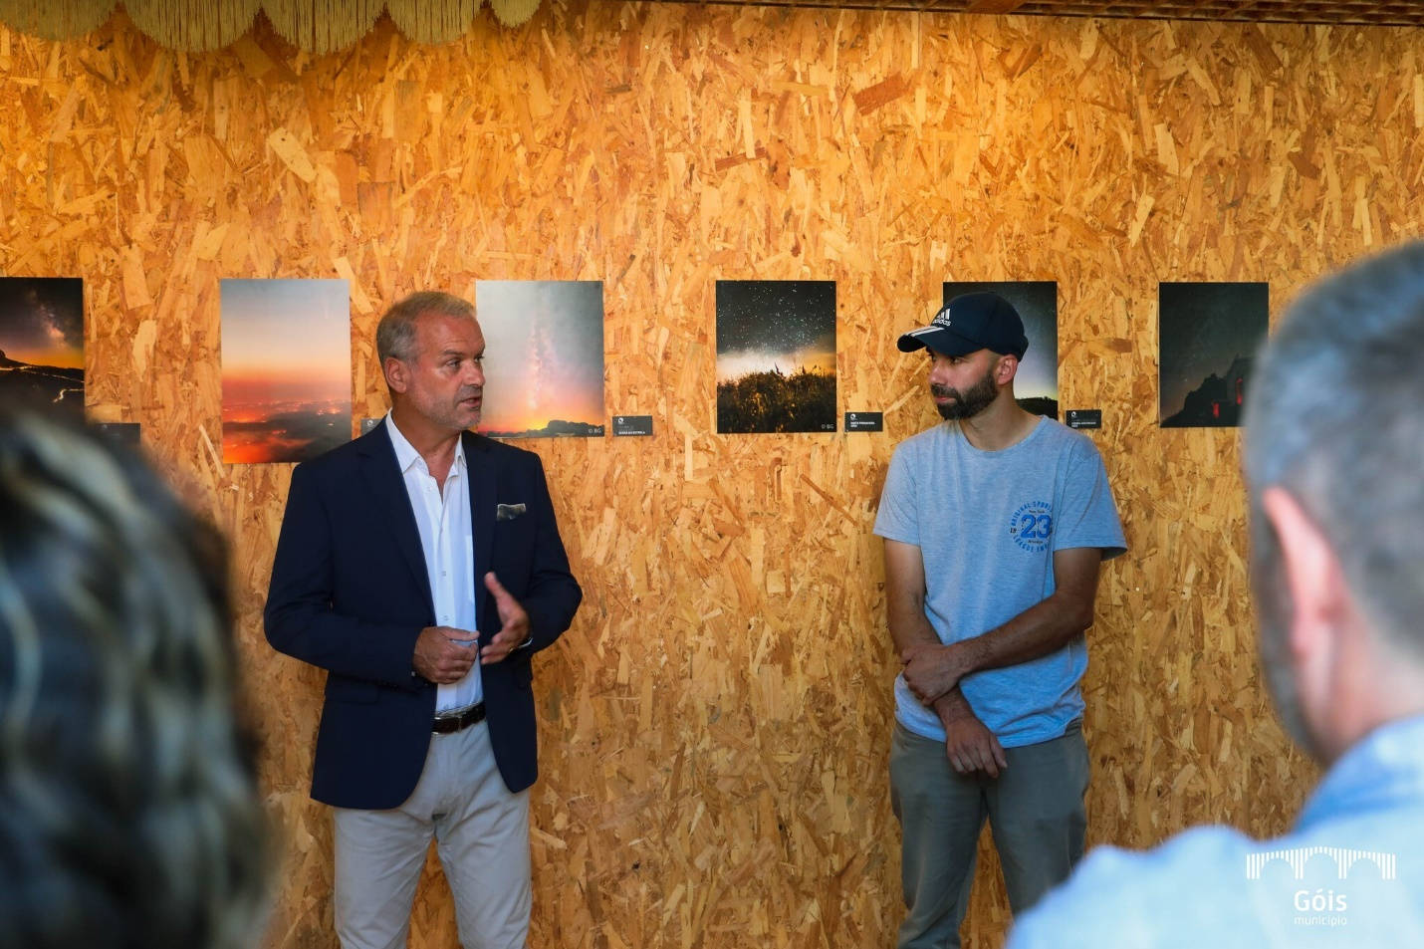
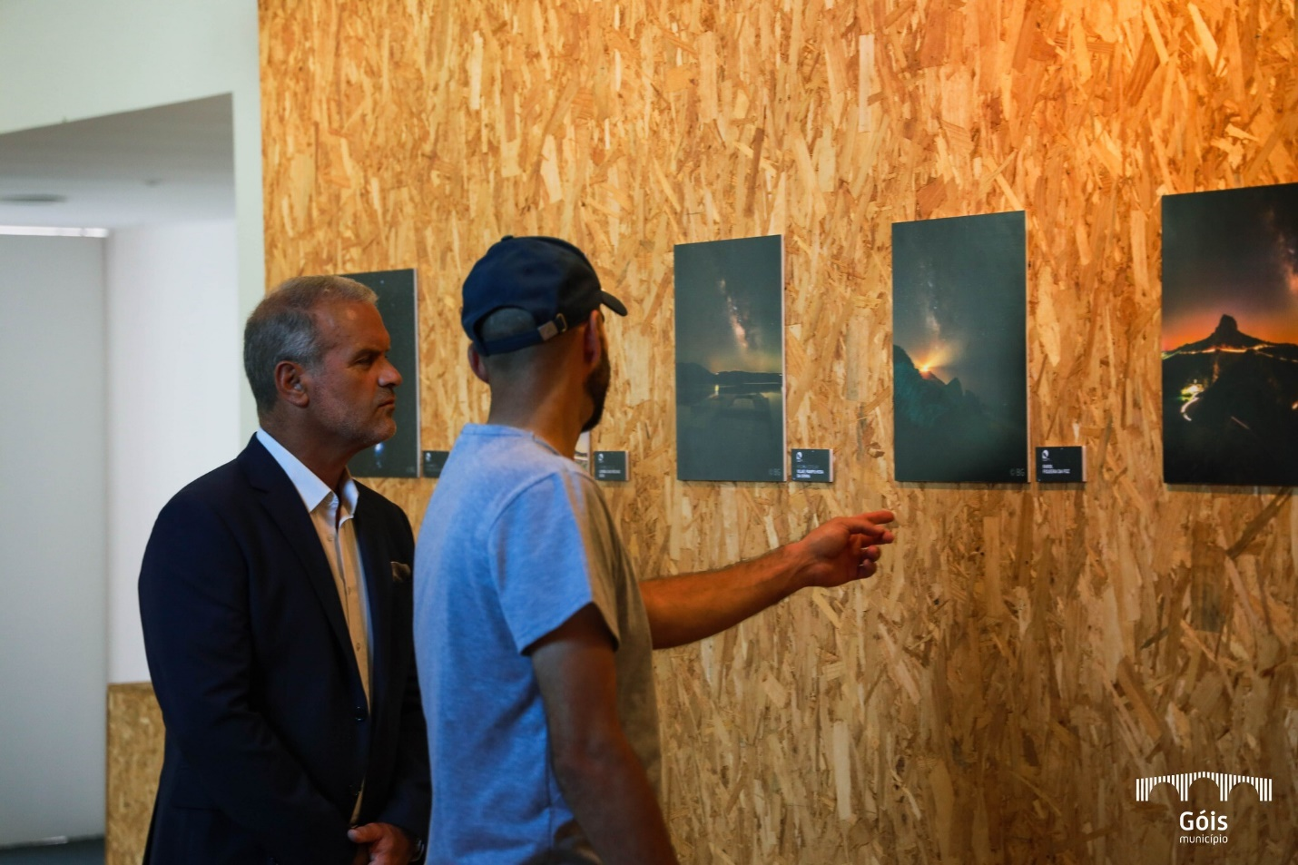
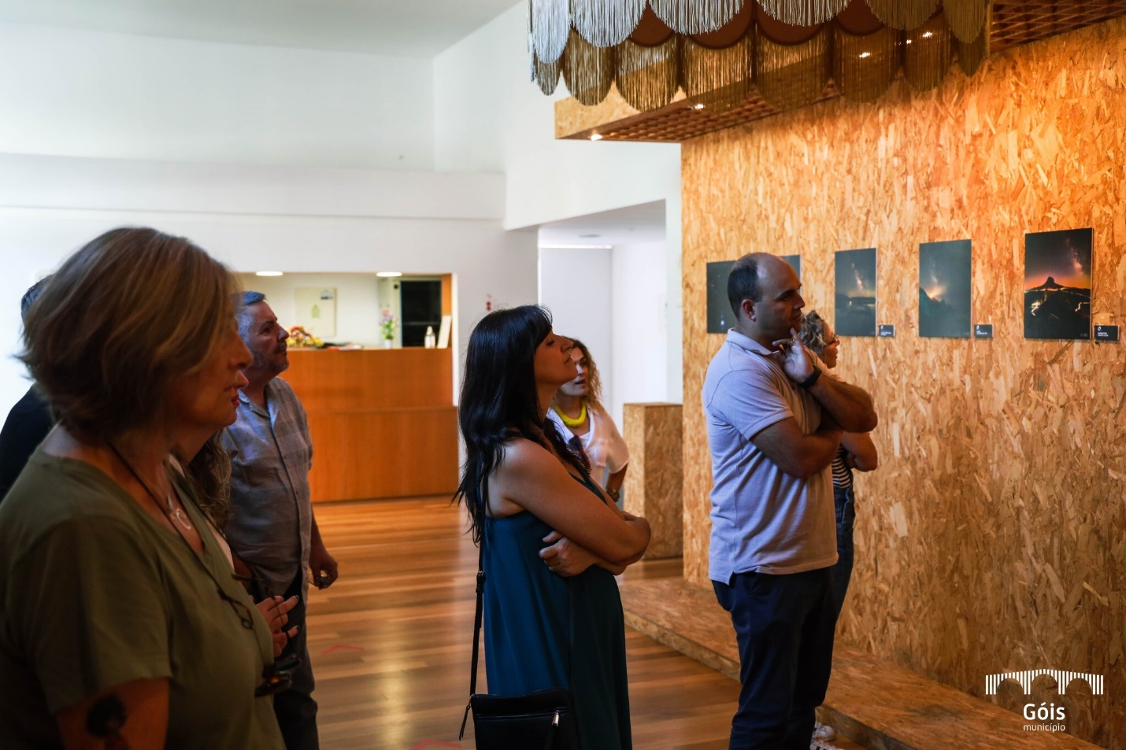

4.
Event Details
Event Name: Semana Mundial do Espaço 2023
Description: Planetarium sessions, talks, rockets launches
Location: Escola Secundária de Gouveia
Date and Time: October 4th
Nature of Event: School event
Number of Participants (if available):
Breakdown by Age Group (if available):
Breakdown by Gender (if available):
Notable Stories:
Please provide any impressive or impactful stories from the event to be considered for a feature in the annual report.
Links to Event Coverage:
https://www.esgouveia.pt/index.php?option=com_content&view=article&id=4200:semana-mundial-do-espaco-resumo&catid=9:escola&Itemid=155
https://esgouveia-my.sharepoint.com/personal/comunicacao_esgouveia_pt/_layouts/15/stream.aspx?id=%2Fpersonal%2Fcomunicacao%5Fesgouveia%5Fpt%2FDocuments%2FVideos%2Fsemana3%2Emp4&nav=eyJyZWZlcnJhbEluZm8iOnsicmVmZXJyYWxBcHAiOiJPbmVEcml2ZUZvckJ1c2luZXNzIiwicmVmZXJyYWxBcHBQbGF0Zm9ybSI6IldlYiIsInJlZmVycmFsTW9kZSI6InZpZXciLCJyZWZlcnJhbFZpZXciOiJNeUZpbGVzTGlua0RpcmVjdCJ9fQ&ga=1&referrer=StreamWebApp%2EWeb&referrerScenario=AddressBarCopied%2Eview

Photos:
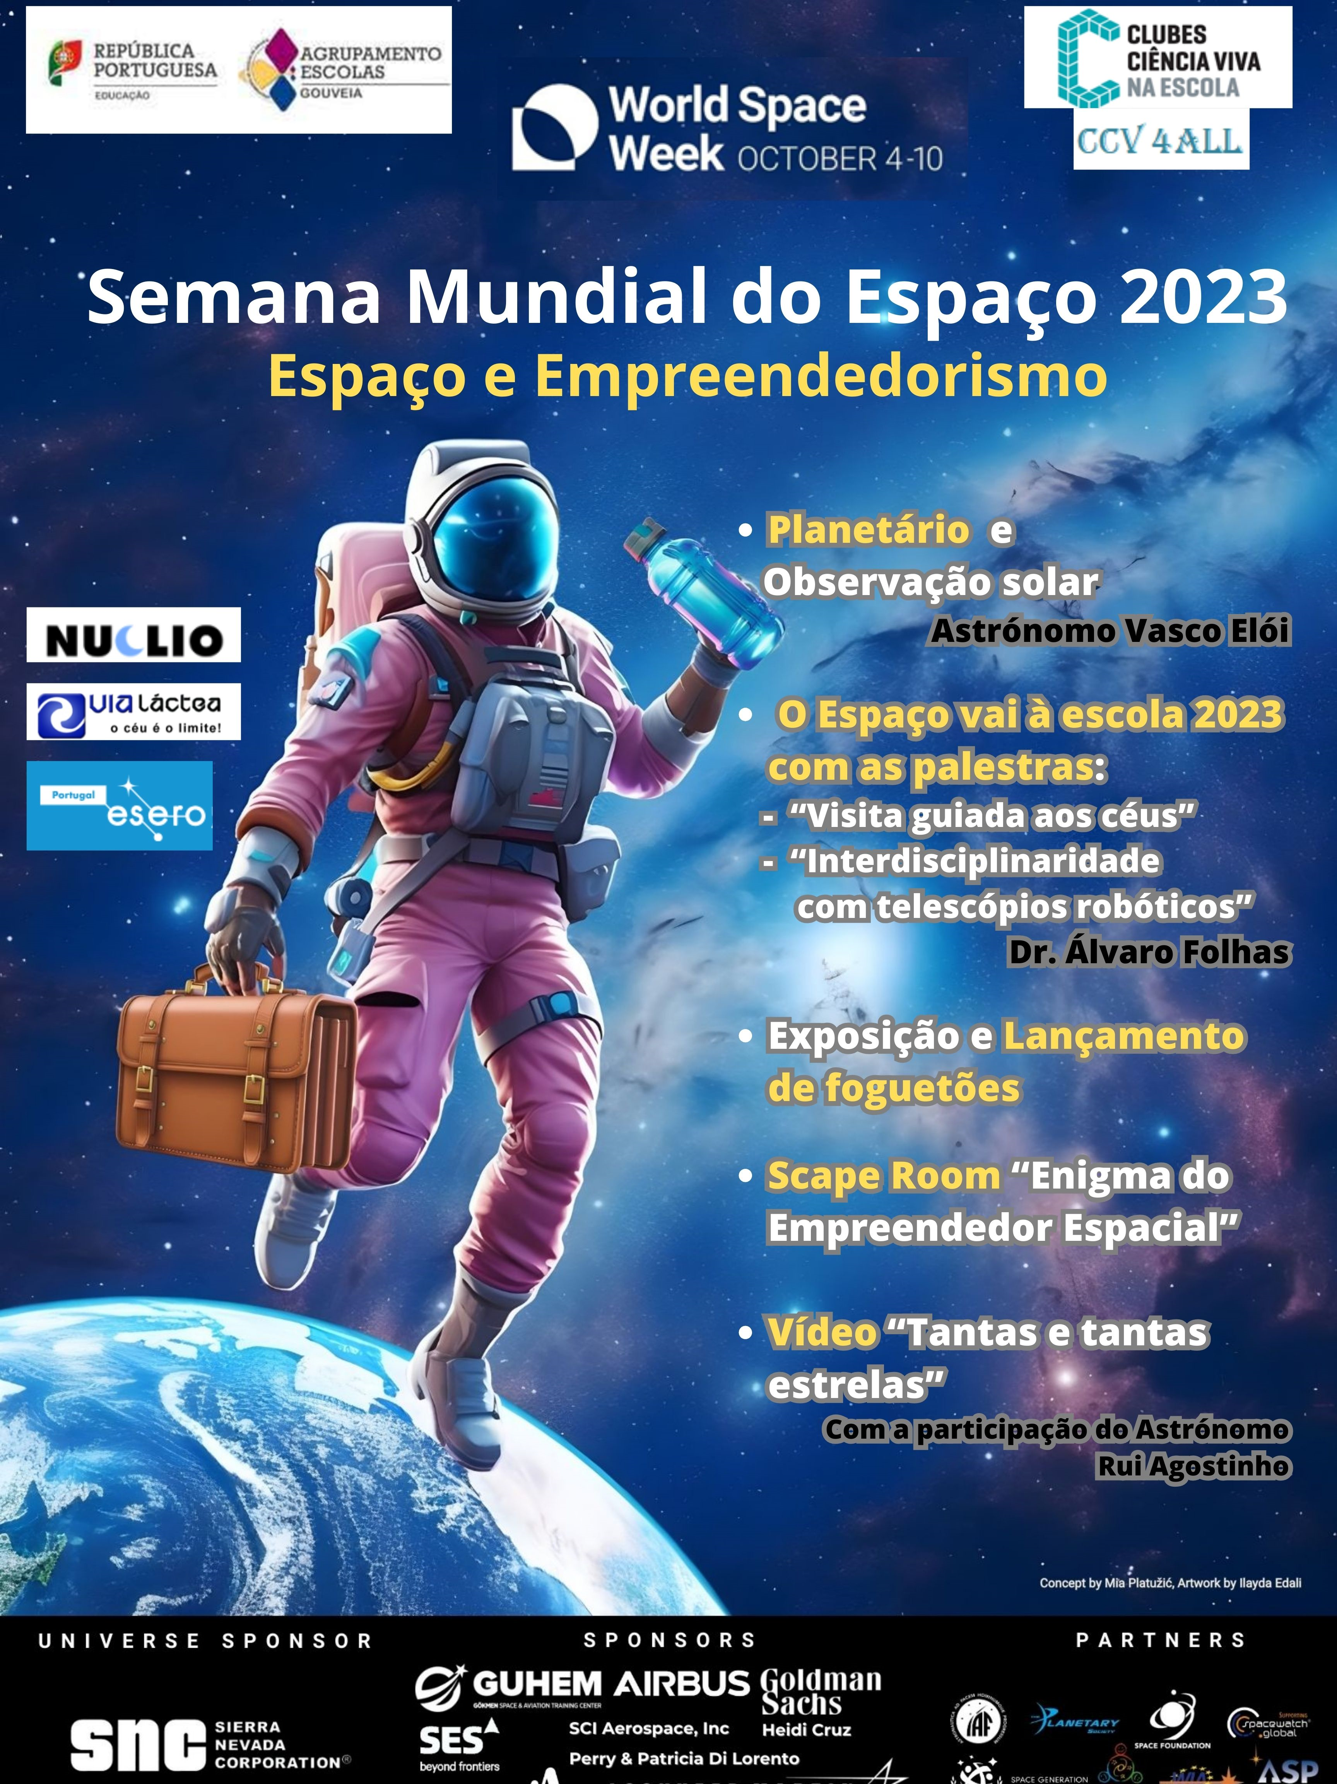
Video: https://esgouveia-my.sharepoint.com/personal/comunicacao_esgouveia_pt/_layouts/15/stream.aspx?id=%2Fpersonal%2Fcomunicacao%5Fesgouveia%5Fpt%2FDocuments%2FVideos%2Fsemana3%2Emp4&nav=eyJyZWZlcnJhbEluZm8iOnsicmVmZXJyYWxBcHAiOiJPbmVEcml2ZUZvckJ1c2luZXNzIiwicmVmZXJyYWxBcHBQbGF0Zm9ybSI6IldlYiIsInJlZmVycmFsTW9kZSI6InZpZXciLCJyZWZlcnJhbFZpZXciOiJNeUZpbGVzTGlua0RpcmVjdCJ9fQ&ga=1&referrer=StreamWebApp%2EWeb&referrerScenario=AddressBarCopied%2Eview

4. Media and Social Media Engagement (if available)
Social Media Impressions
Please provide a platform-wise breakdown:

Media / News Coverage:
You may list as many as possible / available.
Reach (Local, National):

5. Additional Efforts (if available)
1. Press Releases:
https://correiodosacores.pt/NewsDetail/ArtMID/383/ArticleID/45431/Convite-224-Celebra231227o-da-Semana-Mundial

2. Additional Information:
Regular annual communications to Municipalities Association, to Regional Governments of Azores and Madeira (to Education and to Culture Departments), to National Government (Education and Culture Ministries).

