WORLD SPACE WEEK 2023
AZERBAIJAN
NATIONAL REPORT

1. General Information
National Coordinator:
- Full Name: Natavan Hasanova
- Contact Information: nata1.hasanova@gmail.com
2. World Space Week 2023 Azerbaijan Overview
Total Number of Events Conducted: 28
Nature of Events: TV and Radio talk shows, lectures and seminars, panel discussions, startup talks, workshops, master classes, discounts at local bookstores, astronaut meetings, school events, movie night.
Summary of Events:
In total, there have been 28 events and activities carried out during the World Space Week 2023 (WSW23) in Azerbaijan. The purpose of WSW23 in Azerbaijan was to provide unique leverage in space outreach and education, inform people about the benefits they get from space, encourage greater use of space for sustainable economic development, demonstrate public support for space programs, inspire young people about STEAM, and foster international cooperation in space outreach and education.
WSW in Azerbaijan aimed at providing unique opportunities for the development of space and education in this field in the Republic of Azerbaijan. This year’s WSW in Azerbaijan overlapped with the International Astronautical Congress (IAC) 2023. That is why guests coming to IAC23 have been actively engaged in the events and activities of WSW23 in Azerbaijan.
Summary and report of some events:
- Radio and TV appearances:
  - Radio Talk-Show on World Space Week at ASAN FM
On October 9, the Strategy and Business Development Director at Azercosmos as well as the National Coordinator of World Space Week in Azerbaijan Natavan Hasanova has been aired at a “Rəqəmsal dialoq” (Digital dialog) radio talk-show. The overall topic of the radio talk-show was the World Space Week, and Natavan talked about the history and importance of WSW, events and activities carried out within this Week, as well as the International Astronautical Congress that took place in Baku and coincided with the WSW. The Radio Talk-Show was viewed by 1.3K+ people on Facebook.
The link to Radio Talk-Show:
- https://fb.watch/on2Od76ljx/

  - Female Factor with Prof. Pascale Ehrenfreund at CBC International
On October 5, with the support of Azercosmos within the WSW23 in Azerbaijan, former President of the International Astronautical Federation, President of the International Space University Prof. Pascale Ehrenfreund has been interviewed on the Female Factor TV Show broadcast on CBC TV Azerbaijan. In show, Prof. Ehrenfreund discussed the initiative of women in the field of space technology and their successes. Furthermore, she mentioned the roles of startups on space and added her point of view why Space and Entrepreneurship has been chosen as a topic of the World Space Week.
The link to TV Show:
- https://youtu.be/MAWx6QkXUqE?si=dELI_1xURYUlrvY2

- University events:
  - Panel Discussion with SGAC at French-Azerbaijani University
On October 3, a dynamic and informative Panel Discussion hosted by Azercosmos and titled "SGAC's Drive for Innovation in the New Space Era" was held at UFAZ. The event featured four esteemed SGAC delegations who were Tatiana Komorna, Operations Officer at SGAC, Marcos Eduardo Rojas Ramirez, Event Manager at SGAC, Antonio Stark, Regional Coordinator for Asia-Pacific at SGAC, and Alexandra Jercaianu, DGE-PG Member, Co-lead Sponsorship Our Giant Leap Hackathon, UNOOSA Space4Women as speakers, engaging with 25 students from UFAZ and Azerbaijan State Oil and Industry University. The panel served as a platform for shedding light on the activities and initiatives of the Space Generation Advisory Council and explored the multifaceted concept of the "new space era." Speakers discussed the significance of innovation in the ever-evolving space industry and its critical role in shaping the future of space exploration. Throughout the event, participants had the opportunity to gain valuable insights into SGAC's mission and its contributions to fostering innovation in the realm of space.
This event was published on media:
- https://azertag.az/xeber/bakida_kosmik_nesil_mesveret_surasinin_yeni_kosmos_dovrunde_innovasiyaya_desteyi_adli_panel_muzakiresi_teskil_olunub-2774941

  - Space Industry Talks with D-Orbit at Baku Engineering University
On October 4, Azercosmos hosted a captivating and informative event titled Space Industry Talks with D-Orbit at Baku Engineering University (BEU). This event provided a unique opportunity for BEU students to delve into the world of space technology and innovation, facilitated by an expert from D-Orbit. The event has been moderated by Asad Hasanov, representative of Azercosmos, who set the stage for an engaging discussion. The highlight of the event has been the esteemed speaker, Mr. Stefano Antonetti, the Vice President of Business Development at D-Orbit. With his extensive experience and deep knowledge of the space sector, Mr. Antonetti offered valuable insights into the evolving landscape of space technology and innovation.
The event has been widely featured on media:
- https://azedu.az/az/news/72456
- https://beu.edu.az/en/article/vice-president-of-italian-aerospace-company-meets-with-beu-students-1790
- https://azedu.az/az/news/72428
- https://unikal.az/news/399846
- https://modern.az/tehsil/434115
- https://tehsil.biz/news/az/65381/

  - Space Law Workshop at BSU by Steven Hobe and Stephan Freeland
Within WSW23 in Azerbaijan, on October 4, Azercosmos in collaboration with the Baku State University (BSU) hosted a significant Space Law Workshop, featuring esteemed legal scholars Prof. Steven Freeland and Prof. Stephan Hobe. The lecture engaged around 40 students of BSU, delving into crucial topics of Legal Aspects of Space Resource Activities: Issues and Challenges, as well as Space Debris Mitigation and international environmental law. A milestone was reached with the signing of a Memorandum among Azercosmos, Prof. Hobe, and BSU. Professors were honored with certificates of recognition from BSU, marking a scholarly commitment to space law advancements.
The event was featured on media:
- https://baku.news/elm/66152-azerkosmos-bdu-ve-almaniyanin-hava-huququ-kosmos-huququ-ve-kiber-huquq-nstitutu-emekdashliq-edecek.html
- https://moderator.az/az/dunya/688448
- https://moderator.az/az/dunya/688443
- https://tehsil.biz/news/az/65380/
- https://azertag.az/xeber/azerkosmos_bdu_ve_almaniyanin_hava_huququ_kosmos_huququ_ve_kiber_huquq_institutu_emekdasliq_edecek-2774785
- https://azertag.az/xeber/umumdunya_kosmos_heftesi_cherchivesinde_bdu_da_kosmos_huququ_movzusunda_seminar_kechirilib-2774704

  - The Space Science Symposium: Dialogue with Eminent Scientists at Azerbaijan State Oil and Industrial University
The Space Science Symposium: Dialogue with Distinguished Scientists, a collaborative initiative by Azercosmos and Azerbaijan State Oil and Industrial University, took place within the WSW23 in Azerbaijan on October 4. Distinguished scientists, Prof. Dr. Nazim Muradov from University of Central Florida, Prof. Dr. Chingiz Hajiyev from Istanbul Technical University, Prof. Dr. Abdulla Sofiyev from Istanbul Trade University, and Esmira Bayramova, a DevOps Manager from Capella Space, California, engaged in insightful dialogue with around 20 students moderated by Azercosmos representative Asad Hasanov. Dr. Muradov, Dr. Hajiyev, and Dr. Sofiyev shared expertise on space science, while Esmira Bayramova brought a practical industry perspective.
The event was featured on media:
- https://moderator.az/az/dunya/689401
- https://tehsil.biz/news/az/65467/
- https://azedu.az/az/news/72485
- https://azertag.az/xeber/kosmik_elm_simpoziumu_gorkemli_alimlerle_dialoq___adnsu_da_tedbir-2776975
- https://moderator.az/az/dunya/688534
- https://tehsil.biz/news/az/65393/

  - ADA Senior Talks with Space Foundation
As part of the World Space Week 2023 in Azerbaijan, on October 3, Azercosmos in collaboration with the Space Foundation and ADA University organized the next edition of the ADA Senior Talks series featuring Kelly Kedis Ogborn, the Vice-President of Space Commerce and Entrepreneurship at the Space Foundation. Ms. Ogborn shared insights on breaking down the notion that the space does not have to be a rocket science and converted diverse opportunities available for the youth in the field of space. The event concluded on a high note with an engaging Q&A session, where students showcased their curiosity by posing thought-provoking questions to Ms. Ogborn.

  - Cognitive Science and Space Travel Seminar at Baku branch of First Moscow State Medical University
Within the WSW23 in Azerbaijan, the seminar by a third-year medical student at the Royal College of Surgeons of Ireland Laila Kamali, was as an enlightening exploration organized by Azercosmos in collaboration with the Baku branch of First Moscow State Medical University named after I. M. Sechenov. With deep knowledge in cognitive science and space travel, Laila delved into the factors influencing brain cognition in space, and this momentous occasion for knowledge exchange at the intersection of medicine and space exploration intrigued 28 students from the Baku branch of First Moscow State Medical University named after I. M. Sechenov participating at a lecture.

  - Space Meetup at Baku Higher Oil School
Within the framework of the IAC23 and WSW23 in Azerbaijan, Managing Director of the OffWorld Kyle Acierno, and the first Egyptian, Arab with around 200 students at the Baku Higher Oil School. In his presentation, Kyle gave information about OffWorld, its strategy, future plans, areas of use of robots, and production on the Moon. Later, astronaut Sara Sabry spoke about space travel and shared her experience as well as gave her recommendations to students who are interested in this field. In the end, guests answered questions from the students.

  - Stellar Debris Exploration: Detect, Monitor, and Analyze Workshop at National Aviation Academy
On October 4, an enlightening and engaging workshop titled "Stellar Debris Exploration: Detect, Monitor, and Analyze" was hosted by Azercosmos at the National Aviation Academy (NAA). This workshop was featured by six esteemed professorial representatives Dr. Igor Molotov from Keldysh Institute of Applied Mathematics, RAS, Russian Federation, Prof. Ilias Fernini, Mrs. Maryam Sharif, and Ms. Aisha Alowais from Sharjah Academy for Astronomy, Space Sciences and Technology, United Arab Emirates, Dr. Sanat K Biswas from Indraprastha Institute of Information Technology Delhi, India, and moderator Aftab Kalantarly from Azercosmos. The event was specifically designed to foster knowledge exchange and discussions about space debris among students at NAA. Speakers, each hailing from different corners of the globe, brought their unique perspectives and expertise to the discussion. During the event, attendees had the opportunity to explore fundamental discussions surrounding space debris, including its nature, origins, and the significant impact it poses to space activities.

  - Lecture on GIS at Khazar University
On October 9, a leading trainer of a GIS Center at Azercosmos Sona Guliyeva delivered a lecture on GIS at Khazar University. During this lecture, participants gained a comprehensive understanding of GIS with real-life examples of GIS application areas. The lecture featured interactive elements that allowed students to actively participate and ask questions. This interaction contributed to a deeper understanding of GIS principles and their practical applications. Participants had the opportunity to interact with like-minded students and GIS enthusiasts from Khazar University, and this networking opportunity has led to valuable collaborations and partnerships in the field.

  - Lecture on SmallSats at Azerbaijan Technical University
On October 10, a representative of Azercosmos Nadir Atayev delivered a lecture on small satellites at the Azerbaijan Technical University. Around 50 students and faculty gathered to learn more about the wonders of miniature satellites and their big impact on space exploration.

- School events:
  - Seminar and Live Radio-connection with ISS in Baku European Lyceum
In the event, held on October 6, 45 high schoolchildren from school #149 and Baku European Lyceum attended the first-of-its-kind event, live radio-connection with ISS in the Baku European Lyceum. At the beginning of the event, an NPoC of SGAC in Azerbaijan Ali Mammadov delivered an introductory presentation on space, ISS, Azercosmos, as well as the WSW. Later, after a quick coffee break, a connection was established when the ISS was over the west border of our country, and students came one-by-one and, through intercom, asked their questions about the astronauts' lifestyle to a Danish astronaut Andreas Mogensen. The connection lasted roughly 7 minutes. Then students went to the library of the Lyceum to have their 3D printing master class.
Since it was first-of-its-kind event in South Caucasus, it was widely published in media:
- https://ikisahil.az/post/460931
- https://azedu.az/az/news/72478
- https://moderator.az/az/dunya/688994
- https://sia.az/az/news/technology/1094898.html
- https://report.az/ikt/azerbaycanli-mektebliler-beynelxalq-kosmik-stansiya-ile-elaqe-qura-bilibler/
- http://respublik.info/iqtisadiyyat/8538-azerbaycanli-mektebliler-beynelxalq-kosmik-stansiya-ile-elaqe-qura-bilibler.html

  - Lunar Mission Simulation at school-lyceum 83
Within the WSW23 in Azerbaijan, Azercosmos has successfully organized the Lunar Mission Simulation at School-Lyceum 83. 22 schoolchildren displayed exceptional teamwork, innovation, and problem-solving skills as they embarked on a virtual journey to the Moon.
This event was published on media:
- https://azertag.az/xeber/paytaxt_mekteblilerine_ay_missiyasinin_simulyasiyasi_reallasdirilib-2785864
- https://525.az/news/239072-news

  - Astronauts meeting with schoolchildren at Baku European Lyceum
Within the context of WSW23 in Azerbaijan as well as IAC23, on October 4, Azercosmos collaborated with Baku European Lyceum, facilitating an esteemed encounter among Astronauts Julie Payette, Victor Hespanha, Alper Gezeravcı, and the students of Baku European Lyceum. The event comprised a series of sessions, commencing with a welcoming address by Baku European Lyceum Director Zulfiyya Veysova. The highlight of the event was Astronauts Julie Payette, Victor Hespanha, Alper Gezeravci’s comprehensive presentation on space missions, culminating in a dedicated Q&A session.

  - Space Colors Master Class at school N 27
On October 6, in collaboration with Azercosmos, the SGAC and IAF Committee member Alina Vizireanu conducted a Space Colors Master Class for schoolchildren from school N27. During the master class, around 45 schoolchildren listened to a talk on space, addressing the topic from three main areas: (1) humanity, (2) technology & innovation, and (3) the future of space exploration. Then they had an opportunity to express themselves in drawing under the theme “What does Space mean to Me?” and fly the images they were painting outside. Ending the master class, Alina has presented a Knowledge Encyclopedia Space!: The Universe as You've Never Seen it Before to the school.
The event was featured at Azercosmos:
- https://azertag.az/xeber/paytaxt_mekteblilerine_ay_missiyasinin_simulyasiyasi_reallasdirilib-2785864
- https://525.az/news/239072-news

- Events aligned with the topic of the Week:
  - Pitch Deck Master Class
Since the theme of this year’s WSW23 is Space and Entrepreneurship, on October 7, Azercosmos has organized an interactive Pitch Deck master class directed by the Lead Strategy Analyst at Azercosmos Zahra Gasimova. During the first half of the Workshop, Zahra conveyed the idea of how a good pitch deck should be made, what should and should not be included in a good pitch deck, as well as the importance of a Pitch Deck presentation for the startups. Then participants engaged in the practical application of this knowledge by creating and presenting their own pitch deck presentations.

  - Startup Talk with Leanspace
The WSW23 in Azerbaijan witnessed a distinguished event – the Startup Talk featuring Guillaume Tanier, Co-founder and CEO of Leanspace. Held on October 6 at Libraff Park Academy Store, this publicly accessible event attracted a wide audience individuals. Guillaume Tanier, through his role at Leanspace, offered valuable insights, contributing to the event's significance within the broader theme of World Space Week Space and Enterpreneurship. A worthy initiative, the Startup Talk fostered knowledge exchange and inspired innovation in the space entrepreneurial domain.
The video report of the event: https://www.facebook.com/Azercosmosofficial/videos/700146384956797

- Other events and activities:
  - Discounts at Ali and Nino bookstores
With regards to the upcoming WSW23 in Azerbaijan as well as the International Astronautical Congress, on October 1-2, Ali and Nino bookstores set a 30 discount on all space books, and a wide range of space-related books in Azerbaijani, Russian, and English languages have been sold at a discount of 30%.

  - Discounts at Libraff bookstores
Within the WSW23 in Azerbaijan and the International Astronatical Congress, Libraff book stores offered a discount on books related to the universe, space technology, and all things celestial, and a wide range of space-related books in Azerbaijani, Russian, Turkish, and English languages have been sold at a discount of 30%.

  - Meeting with astronauts at RUGIM
On October 5, with the initiative of Azercosmos, astronauts Dumitru Dorin Prinariu and Victor Hespanha met with the around 100 schoolchildren at RUGIM. At this meeting, astronauts have told young people about their invaluable experiences in open space, interesting events that have happened to them, and the diversity of space. The highpoint of the event featured by the Q&A session with the schoolchildren.
This event was featured on media:
- https://azedu.az/az/news/72463
- https://azertag.az/xeber/respublika_usaq_gencler_inkisaf_merkezinde_astronavtlarla_gorus_olub-2775976

  - Space Talk on the Search for Life in the Universe
On October 3, Azercosmos in collaboration with Tusi Bohm Planetarium hosted a Space Talk on the Search for Life in the Universe featuring a former Associate Administrator for the Science Mission Directorate at NASA, Professor and Leader of the Space Programs at ETH Zurich Dr. Thomas Zurbuchen and a Senior Physics editor at Quanta magazine Dr. Nadia Drake. 55 amateur scientists and space enthusiasts have participated at the Space Talk featuring the importance of maintaining Earth's health for the pursuit of extraterrestrial life. The core message emphasized the necessity of preserving our planet to facilitate potential discoveries beyond.
Video report:
- https://www.facebook.com/Azercosmosofficial/videos/616114864020664

  - Facebook Live Webinar: The Story of Romeo and Juliet: the Earth and Moon
On October 8, a representative of Azercosmos Asad Hasanov went live on Instagram to talk about our Moon. 247 viewers watched as he told stories from mythologies of Ancient China and Greece about Moon, and further looked at the Moon, its formation and its role in our lives from a scientific point of view. The webinar was interactive, questions and answers were exchanged by the end of the webinar.

  - Space Movie Night by ADA Space Club
On October 6, ADA Space Club organized a Space movie night at ADA University. The night was dedicated to a movie Sunshine where s a group of astronauts on a dangerous mission to reignite the dying Sun, and it was watched by 245 students not only from host, but also from other universities.

  - Space through the eyes of children Drawing Competition by Bilim Baku
A drawing competition "Space through the eyes of children" that has been held on the theme "My cosmic adventure" within the WSW23 in Azerbaijan by Bilim Baku. 62 children have participated on the competition, and five of them: Rugayya Aghamoghlanova, Ayla Bayramova, Aylin Baghirova, Dalgha Yunus, and Ali Fataliyev have been selected as winners. The winners will receive special gifts from Bilim Baku in a separate event.

  - The seminar on the Role of Satellite Technology in Transport Management
The seminar on the Role of Satellite Technology in Transport Management has been jointly organized by Profit Academy and Azercosmos. Tools, data and technologies necessary for traffic regulation were discussed at the seminar attended by around 25 people.
This event was featured on media:
- https://azertag.az/xeber/peyk_texnologiyalarinin_neqliyyatin_idare_olunmasinda_rolu_muzakire_olunub-2789476

3. Highlighted Events and Stories
1. Event Details
Event Name: Female Factor with Prof. Pascale Ehrenfreund at CBC International
Description: On October 5, with the support of Azercosmos within the WSW23 in Azerbaijan, former President of the International Astronautical Federation, President of the International Space University Prof. Pascale Ehrenfreund has been interviewed on the Female Factor TV Show broadcast on CBC TV Azerbaijan. In show, Prof. Ehrenfreund discussed the initiative of women in the field of space technology and their successes. Furthermore, she mentioned the roles of startups on space and added her point of view why Space and Entrepreneurship has been chosen as a topic of the World Space Week.
Location: CBC TV Azerbaijan
Date and Time: October 5, 4:30 PM
Nature of Event: Public Appearance
Links to Event Coverage:
https://youtu.be/MAWx6QkXUqE?si=dELI_1xURYUlrvY2
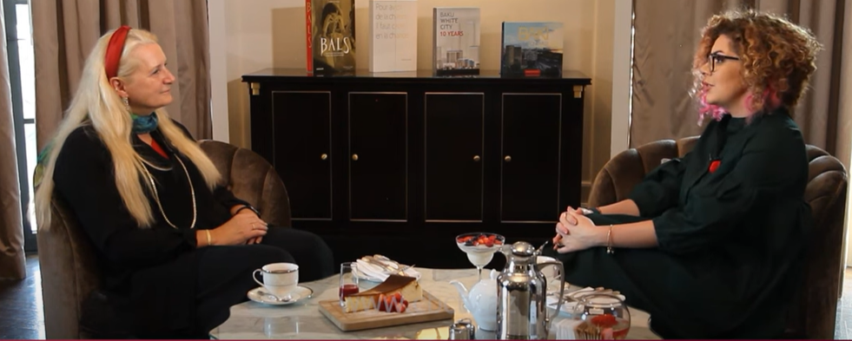

2. Event Details
Event Name: Radio Talk-Show on World Space Week at ASAN FM
Description: On October 9, the Strategy and Business Development Director at Azercosmos as well as the National Coordinator of World Space Week in Azerbaijan Natavan Hasanova has been aired at a “Rəqəmsal dialoq” (Digital dialog) radio talk-show. The overall topic of the radio talk-show was the World Space Week, and Natavan talked about the history and importance of WSW, events and activities carried out within this Week, as well as the International Astronautical Congress that took place in Baku and coincided with the WSW. The Radio Talk-Show was viewed by 1.3K+ people on Facebook.
Location: ASAN FM
Date and Time: October 9, 7:30 PM
Nature of Event: Public Appearance
Links to Event Coverage: https://fb.watch/on2Od76ljx/
Photos: 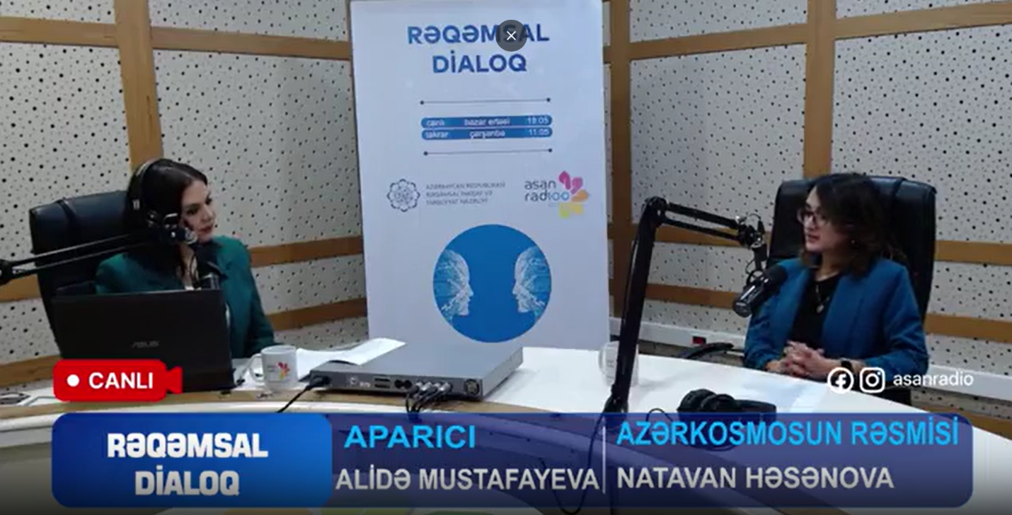

3.
Event Details
Event Name: Seminar and Live Radio-connection with ISS in Baku European Lyceum
Since it was first-of-its-kind event in South Caucasus, it was widely published in media:
Description: In the event, held on October 6, 45 high schoolchildren from school #149 and Baku European Lyceum attended the first-of-its-kind event, live radio-connection with ISS in the Baku European Lyceum. At the beginning of the event, an NPoC of SGAC in Azerbaijan Ali Mammadov delivered an introductory presentation on space, ISS, Azercosmos, as well as the WSW. Later, after a quick coffee break, a connection was established when the ISS was over the west border of our country, and students came one-by-one and, through intercom, asked their questions about the astronauts' lifestyle to a Danish astronaut Andreas Mogensen. The connection lasted roughly 7 minutes. Then students went to the library of the Lyceum to have their 3D printing master class.
Location: Baku European Lyceum
Date and Time: October 6, 11:00 AM
Nature of Event: School event
Number of Participants: 45
Notable Stories: Schoolchildren asked their questions about the astronauts' lifestyle to a Danish astronaut Andreas Mogensen who was in ISS.
Links to Event Coverage:
- https://www.instagram.com/reel/CyETO9oLp7H/?utm_source=ig_web_copy_link&igshid=MzRlODBiNWFlZA==
- https://ikisahil.az/post/460931
- https://azedu.az/az/news/72478
- https://moderator.az/az/dunya/688994
- https://sia.az/az/news/technology/1094898.html
- https://report.az/ikt/azerbaycanli-mektebliler-beynelxalq-kosmik-stansiya-ile-elaqe-qura-bilibler/
- http://respublik.info/iqtisadiyyat/8538-azerbaycanli-mektebliler-beynelxalq-kosmik-stansiya-ile-elaqe-qura-bilibler.html
Photos: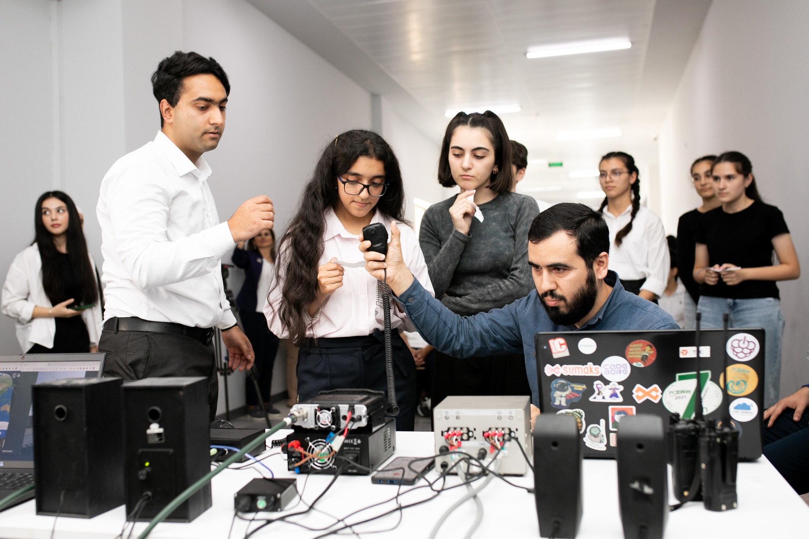
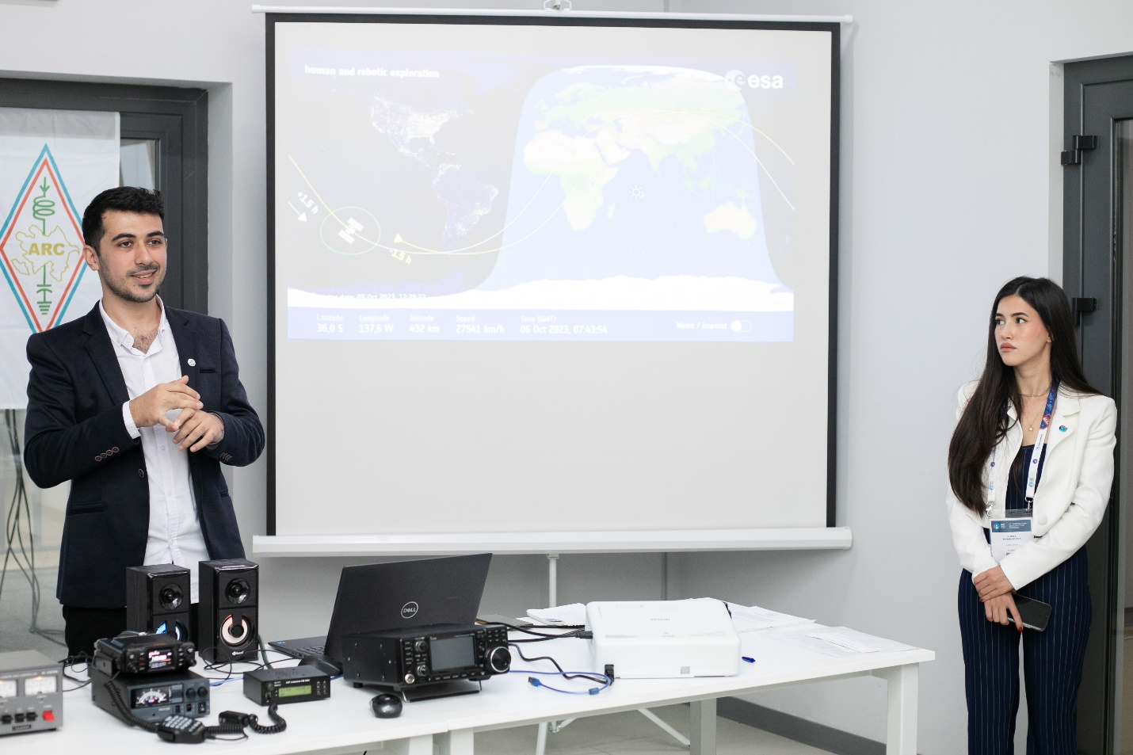
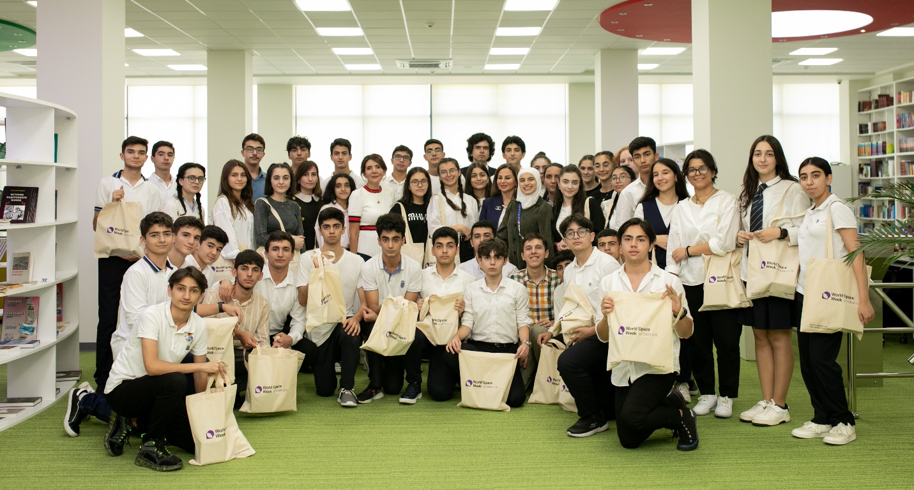

4
Event Details
Event Name: Space Meetup with Astronaut and Industry Expert at Baku Higher Oil School
Description: Within the framework of the IAC23 and WSW23 in Azerbaijan, Managing Director of the OffWorld Kyle Acierno, and the first Egyptian, Arab with around 200 students at the Baku Higher Oil School. In his presentation, Kyle gave information about OffWorld, its strategy, future plans, areas of use of robots, and production on the Moon. Later, astronaut Sara Sabry spoke about space travel and shared her experience as well as gave her recommendations to students who are interested in this field. In the end, guests answered questions from the students.
Location: Baku Higher Oil School
Date and Time: October 5, 4:00 PM
Nature of Event: meet-up
Number of Participants: 200
Photos:
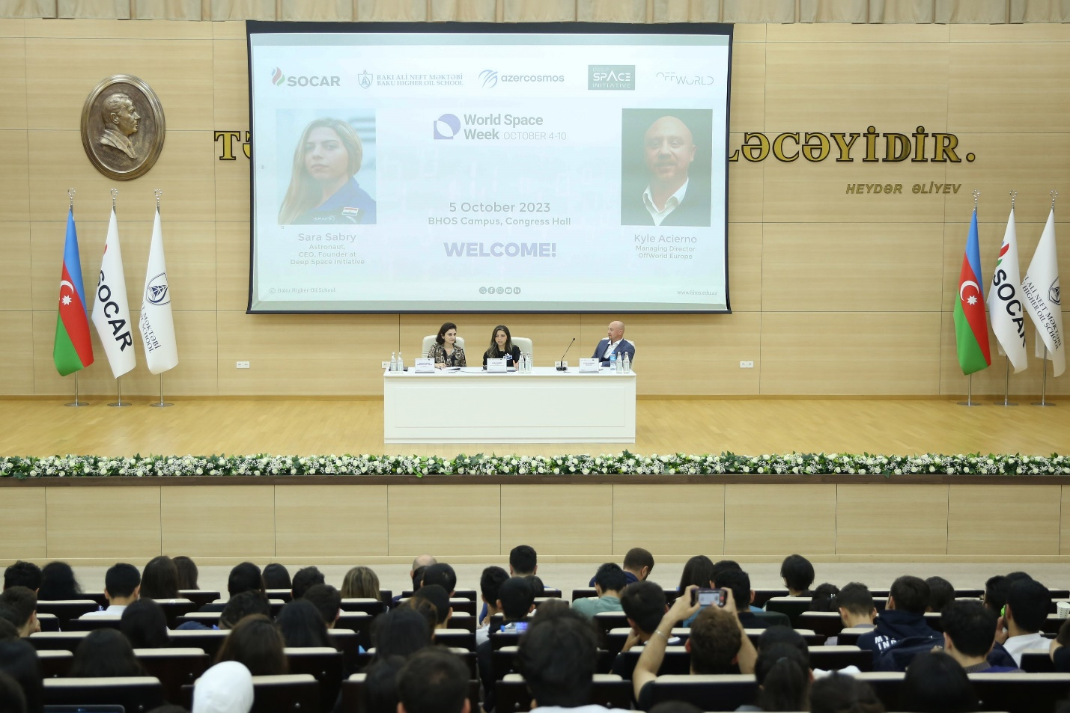
5
Event Details
Event Name: Startup Talk with Leanspace
Description: The WSW23 in Azerbaijan witnessed a distinguished event – the Startup Talk featuring Guillaume Tanier, Co-founder and CEO of Leanspace. Held on October 6 at Libraff Park Academy Store, this publicly accessible event attracted a wide audience individuals. Guillaume Tanier, through his role at Leanspace, offered valuable insights, contributing to the event's significance within the broader theme of World Space Week Space and Enterpreneurship. A worthy initiative, the Startup Talk fostered knowledge exchange and inspired innovation in the space entrepreneurial domain.
Location: Libraff bookstore
Date and Time: October 6, 6:00 PM
Nature of Event: meet-up
Number of Participants: 20
Links to Event Coverage:
https://www.facebook.com/Azercosmosofficial/videos/700146384956797
Photos:
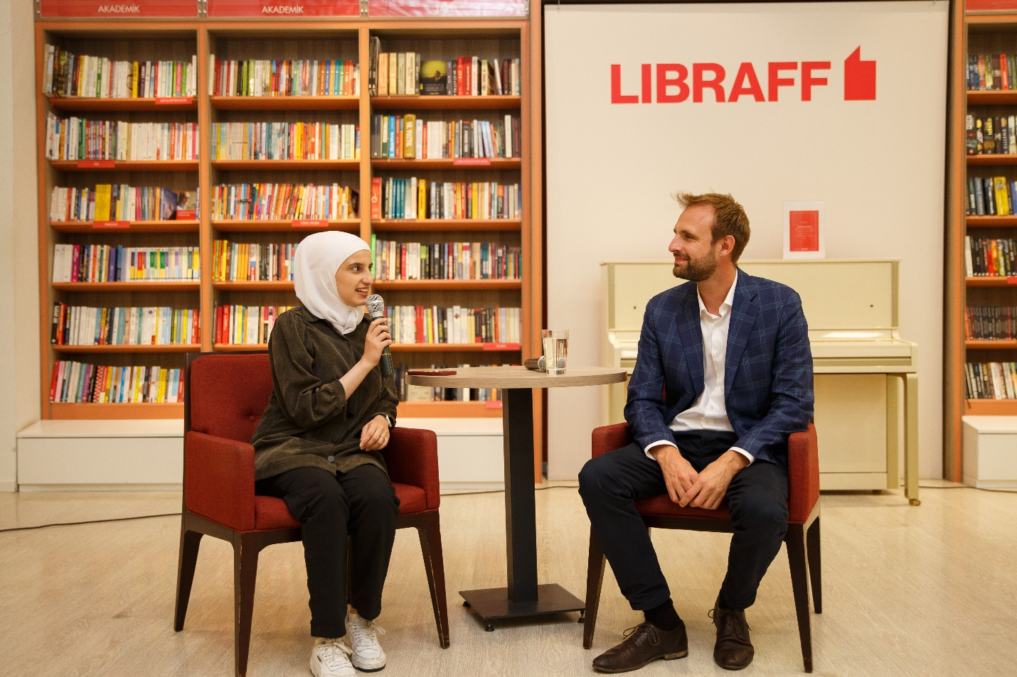
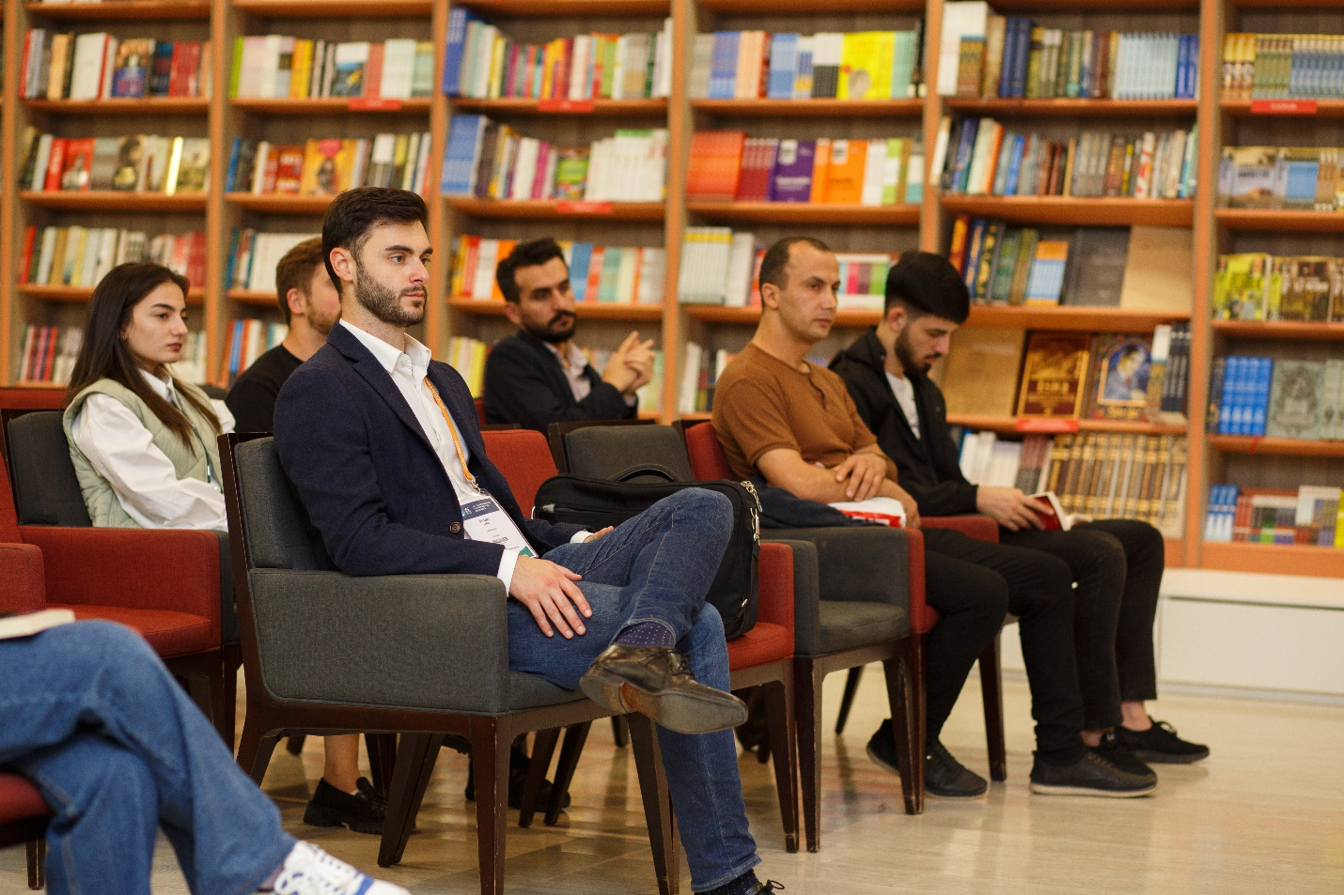
6
Event Details
Event Name: Space Talk on the Search for Life in the Universe
Description:On October 3, Azercosmos in collaboration with Tusi Bohm Planetarium hosted a Space Talk on the Search for Life in the Universe featuring a former Associate Administrator for the Science Mission Directorate at NASA, Professor and Leader of the Space Programs at ETH Zurich Dr. Thomas Zurbuchen and a Senior Physics editor at Quanta magazine Dr. Nadia Drake. 55 amateur scientists and space enthusiasts have participated at the Space Talk featuring the importance of maintaining Earth's health for the pursuit of extraterrestrial life. The core message emphasized the necessity of preserving our planet to facilitate potential discoveries beyond.
Location: Tusi Bohm Planetarium
Date and Time: October 3, 7:30 PM
Nature of Event: meet-up
Number of Participants: 55
Links to Event Coverage: https://www.facebook.com/Azercosmosofficial/videos/616114864020664
Photos:
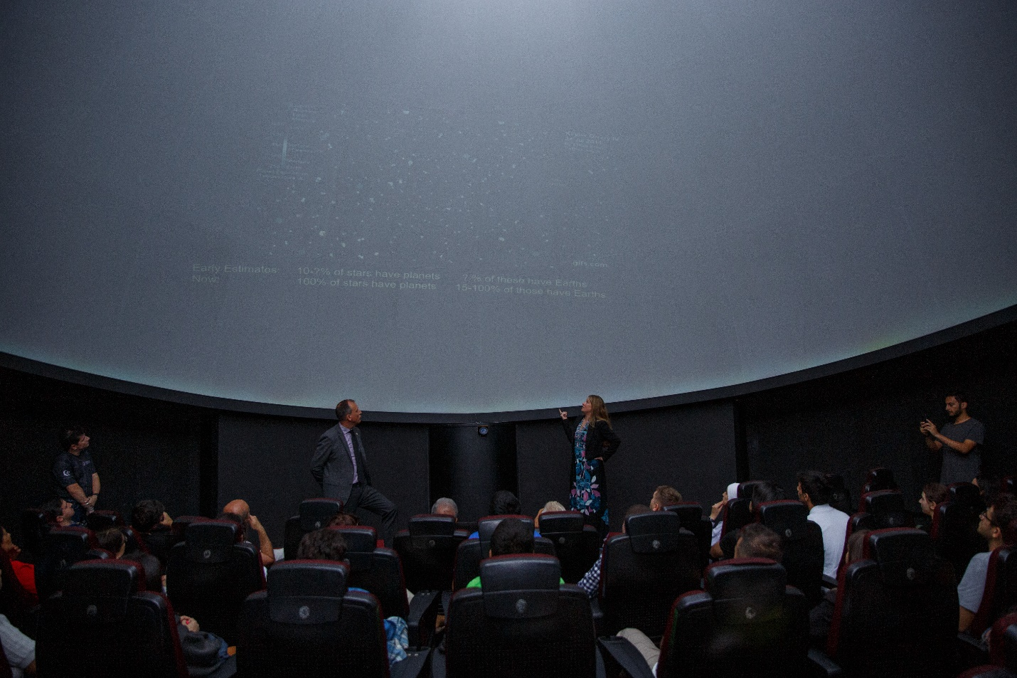
7
Event Details
Event Name: Space Colors Master Class at school N 27
Description: On October 6, in collaboration with Azercosmos, the SGAC and IAF Committee member Alina Vizireanu conducted a Space Colors Master Class for schoolchildren from school N27. During the master class, around 45 schoolchildren listened to a talk on space, addressing the topic from three main areas: (1) humanity, (2) technology & innovation, and (3) the future of space exploration. Then they had an opportunity to express themselves in drawing under the theme “What does Space mean to Me?” and fly the images they were painting outside. Ending the master class, Alina has presented a Knowledge Encyclopedia Space!: The Universe as You've Never Seen it Before to the school.
The event was featured at Azercosmos:
Location: School #27
Date and Time: October 6, 11:00 AM
Nature of Event: School event
Number of Participants: 45
Links to Event Coverage:
- https://azertag.az/xeber/paytaxt_mekteblilerine_ay_missiyasinin_simulyasiyasi_reallasdirilib-2785864
- https://525.az/news/239072-news
Photos:
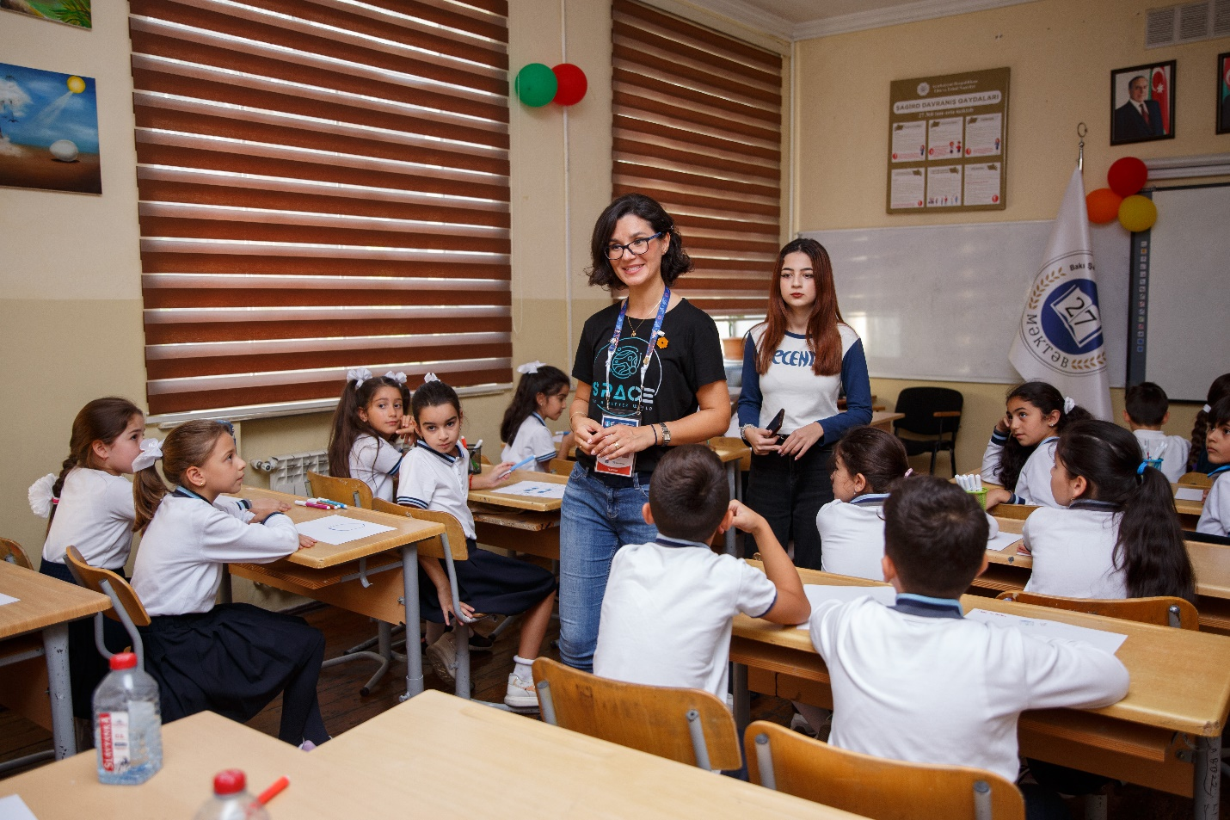
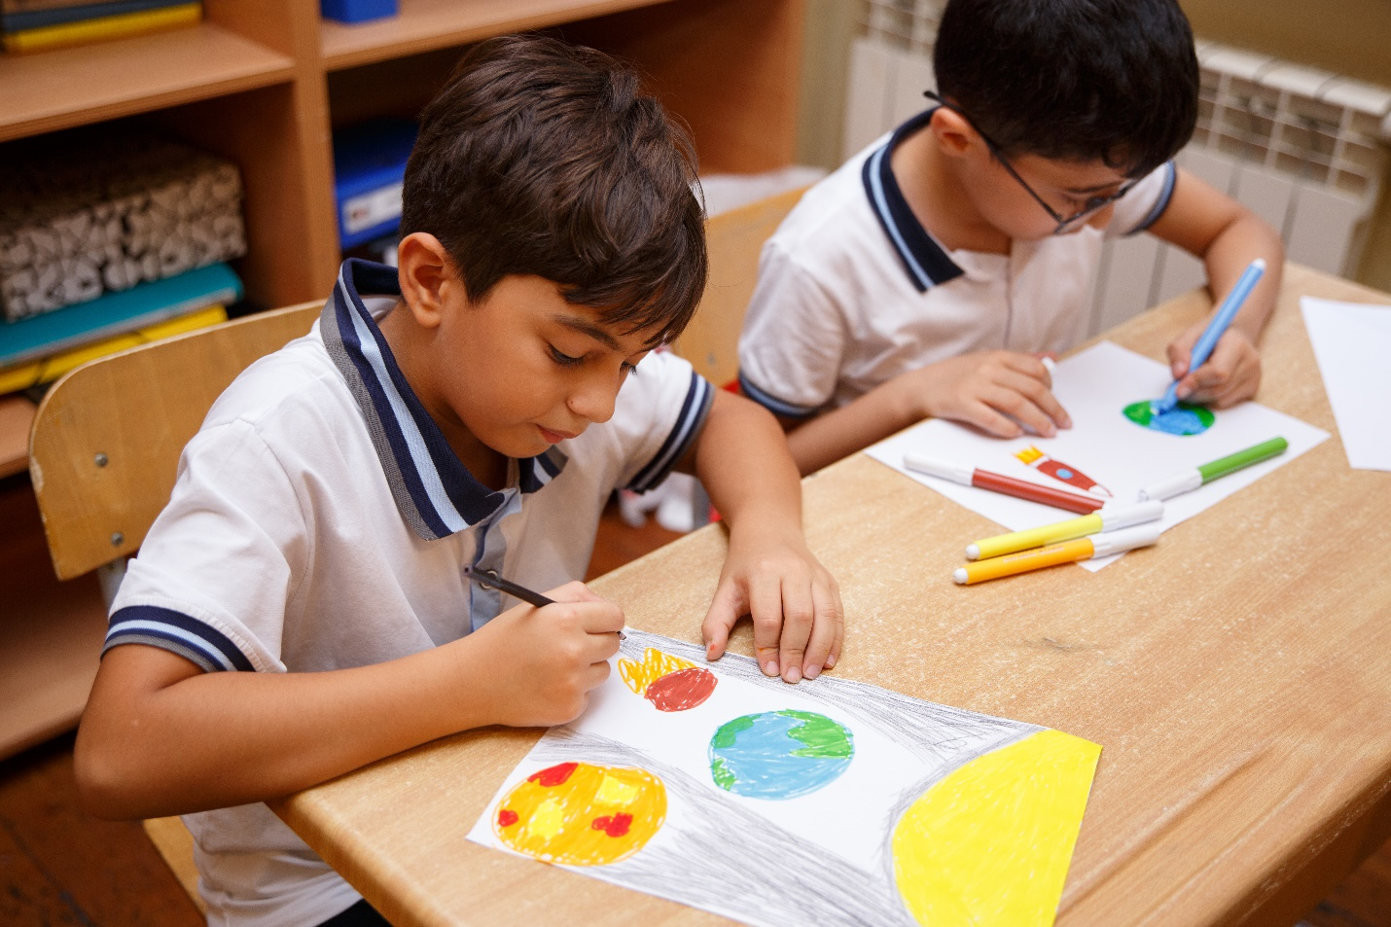
4. Media and Social Media Engagement (if available)
SUMMARY
FACEBOOK REACH & ENGAGEMENTS | 18753 | 1636
LINKEDIN IMPRESSIONS & ENGAGEMENTS | 5162 | 250
INSTAGRAM REACH & ENGAGEMENTS | 25728 | 2365
TWITTER IMPRESSIONS & ENGAGEMENTS | 452 | 15

Media / News Coverage:
- https://azertag.az/xeber/peyk_texnologiyalarinin_neqliyyatin_idare_olunmasinda_rolu_muzakire_olunub-2789476
- https://azertag.az/xeber/paytaxt_mekteblilerine_ay_missiyasinin_simulyasiyasi_reallasdirilib-2785864
- https://525.az/news/239072-news
- https://azertag.az/xeber/azerkosmos_yerli_universitetlerde_maariflendirici_sessiyalar_kechirib-2783155
- https://moderator.az/az/dunya/689401
- https://tehsil.biz/news/az/65467/
- https://azedu.az/az/news/72485
- https://azertag.az/xeber/kosmik_elm_simpoziumu_gorkemli_alimlerle_dialoq___adnsu_da_tedbir-2776975
- https://moderator.az/az/dunya/688534
- https://tehsil.biz/news/az/65393/
- https://ikisahil.az/post/460931
- https://azedu.az/az/news/72478
- https://moderator.az/az/dunya/688994
- https://sia.az/az/news/technology/1094898.html
- https://report.az/ikt/azerbaycanli-mektebliler-beynelxalq-kosmik-stansiya-ile-elaqe-qura-bilibler/
- http://respublik.info/iqtisadiyyat/8538-azerbaycanli-mektebliler-beynelxalq-kosmik-stansiya-ile-elaqe-qura-bilibler.html
- https://oxu.az/society/786526
- https://azedu.az/az/news/72463
- https://azertag.az/xeber/respublika_usaq_gencler_inkisaf_merkezinde_astronavtlarla_gorus_olub-2775976
- https://azedu.az/az/news/72456
- https://beu.edu.az/en/article/vice-president-of-italian-aerospace-company-meets-with-beu-students-1790
- https://azedu.az/az/news/72428
- https://unikal.az/news/399846
- https://modern.az/tehsil/434115
- https://tehsil.biz/news/az/65381/
- https://baku.news/elm/66152-azerkosmos-bdu-ve-almaniyanin-hava-huququ-kosmos-huququ-ve-kiber-huquq-nstitutu-emekdashliq-edecek.html
- https://moderator.az/az/dunya/688448
- https://moderator.az/az/dunya/688443
- https://tehsil.biz/news/az/65380/
- https://azertag.az/xeber/azerkosmos_bdu_ve_almaniyanin_hava_huququ_kosmos_huququ_ve_kiber_huquq_institutu_emekdasliq_edecek-2774785
- https://azertag.az/xeber/umumdunya_kosmos_heftesi_cherchivesinde_bdu_da_kosmos_huququ_movzusunda_seminar_kechirilib-2774704
- https://azertag.az/xeber/bakida_kosmik_nesil_mesveret_surasinin_yeni_kosmos_dovrunde_innovasiyaya_desteyi_adli_panel_muzakiresi_teskil_olunub-2774941
- https://respublika-news.az/news/olkemiz-beynelxalq-astronavtika-konqresine-novbeti-defe-ev-sahibliyi-edecek
- https://musavat.com/news/azerkosmos-umumdunya-kosmos-heftesine-hazirlasir_1009854.html
- https://azertag.az/ru/xeber/azerkosmos_gotovitsya_k_vsemirnoi_nedele_kosmosa-2768068
- https://report.az/ru/ikt/azerkosmos-gotovitsya-k-vsemirnoj-nedele-kosmosa/
- https://azertag.az/xeber/azerkosmos_umumdunya_kosmos_heftesine_hazirlasir-2767756
- https://unikal.az/news/399042
- https://modern.az/tehsil/433280
- https://report.az/ikt/azerbaycanda-2-ci-defe-umumdunya-kosmos-heftesi-kecirilecek/

5. Additional Efforts (if available)
1. Press Releases on Azerbaijan and Azercosmos’ preparation for WSW23:
- https://respublika-news.az/news/olkemiz-beynelxalq-astronavtika-konqresine-novbeti-defe-ev-sahibliyi-edecek
- https://musavat.com/news/azerkosmos-umumdunya-kosmos-heftesine-hazirlasir_1009854.html
- https://azertag.az/ru/xeber/azerkosmos_gotovitsya_k_vsemirnoi_nedele_kosmosa-2768068
- https://report.az/ru/ikt/azerkosmos-gotovitsya-k-vsemirnoj-nedele-kosmosa/
- https://azertag.az/xeber/azerkosmos_umumdunya_kosmos_heftesine_hazirlasir-2767756
- https://unikal.az/news/399042
- https://modern.az/tehsil/433280
- https://report.az/ikt/azerbaycanda-2-ci-defe-umumdunya-kosmos-heftesi-kecirilecek/

