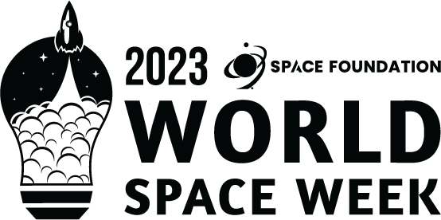

WORLD SPACE WEEK 2023
United States
NATIONAL REPORT

1. General Information
National Coordinator:
Full Name: Rich Cooper/Emily Normandy
Contact Information (Email, Phone): rcooper@spacefoundation.org – 719-576-8000

2. World Space Week 2023 (Your Country) Overview
Total Number of Events Conducted: 26
Nature of Events
Convention, summit, school events, solar eclipse community gatherings, field trips, expo, community enrichment programs, park dedication, library Q&A with an Astronomer, public outreach, space-inspired school week, workshops, organ concert, networking event, space ethics discussion, MaxIQ Space Awards, art contest launch, advocacy series.
Summary of Events:

3. Highlighted Events and Stories
1. Event Details
Event Name: Space City Soundscapes: An Organ Concert of Cosmic Proportions
Description: St. Luke’s Organist & Artist-in-Residence, Jim Roman, presents a concert of music inspired by outer space. Selections will include music from movies like 2001: A Space Odyessy, Arrival, Interstellar and Star Wars in addition to original organ music such as James Whitbourn’s ‘Apollo’, a work commissioned by the performer in 2019 that tells the story of NASA’s Apollo 8 space flight through music.
Location: St. Luke’s United Methodist Church (3471 Westheimer Road, Houston, TX 77027)
Date and Time: Tuesday, October 10, 2023 | 7pm
Nature of Event: Concert
Number of Participants: Approx. 100
Notable Stories:
Links to Event Coverage:
Event age: https://rock.stlukesmethodist.org/event-details?EventOccurrenceId=1834
Event recording (excerpt): Interstellar Suite

Photos: Dropbox Photos

2. Event Details
Event Name: Lights Out: Experiencing A Solar Eclipse
Description: Space Foundation Discovery Center is hosted a day to celebrate the Annular Eclipse of 2023!
We observed the October 2023 Annular Eclipse. Families will receive a free pair of eclipse glasses to take home, in addition to receiving resources to prepare for the April 2024 Total Solar Eclipse.
We had The Chamber Orchestra of Colorado Springs, the region’s foremost chamber music ensemble played for us. The Colorado Springs Astronomical Society (CSASTRO) also joined us with their solar telescopes.
We had workshops, guests speakers, activities, and a great sense of community excited about space.
Location: 4425 Arrowswest Drive, Colorado Springs, CO 80907 USA
Date and Time: October 14, 2023 | 9:00am-4:00pm MDT
Nature of Event: Community
Number of Participants: Approx. 630
Links to Event Coverage:
https://gazette.com/multimedia/photos-partial-solar-eclipse-visible-at-space-foundation-discovery-center/collection_61595bec-6acf-11ee-b7c0-0b3792254959.html#3
Photos: https://www.flickr.com/photos/space_foundation/albums/72177720312318820

4. Media and Social Media Engagement (if available)
Social Media Impressions
(For Space Foundation)
14 Posts
Over 10,000 Impressions
Over 3,600 Users Reached
LinkedIn was our most engaged audience

Media / News Coverage:
NA

5. Additional Efforts (if available)
1. Press Releases:
(For Space Foundation)
Space Foundation distributed the World Space Week press release at 7 a.m. MST on Sept.19, 2023 via Meltwater.
The press release was sent to 331 contacts, including Local CO (130) and National (265). The open rate was 23.26 percent with 70 opened, 231 unopened and 7 bounced.
Some of the more notable opens were from Associated Press, USAToday, Space News, Forbes, Wall Street Journal, Bloomberg, CNN, CNBC, Fast Company, and NasaSpaceFlight.

